**The Challenges and opportunities of online teaching during COVID-19 pandemic.**

**Were Vincent**

**12/10/2024Declaration**

I hereby declare that this research dissertation work being presented is my own original work titled “The Challenges and Opportunities of Online Teaching During the COVID-19 Pandemic”. All the content that has been used from other sources has been fully acknowledged and cited as per the guidelines of the course. This dissertation has not been submitted for any degree or examination at any other institution.

Signed,

{Name}

[Date]

**Acknowledgments**

Special thanks and gratitude to my supervisor, [**Supervisor’s Name**], for their invaluable guidance, support, and encouragement throughout this research journey. Your insights and feedback were instrumental in shaping this dissertation.

I extend my heartfelt thanks to the faculty members and educators who participated in this study. Your willingness to share your experiences made this research possible, and I am truly grateful for your time and contributions.

To my family and friends, thank you for your constant support and patience during the challenges of this journey. Your encouragement kept me motivated and focused throughout.

Lastly, I would like to acknowledge the academic staff at [**University Name**] for their ongoing support and the learning environment they have provided.

**Dedication**

This dissertation is dedicated to my family, for their unwavering belief in me, and to all educators worldwide, who have demonstrated resilience and adaptability in the face of unprecedented challenges during the COVID-19 pandemic. Your dedication to education and your students continues to inspire me.

**Abstract**

In the light of COVID-19 affecting the entire world the traditional face to face method/ style of teaching was switched to online in a record time and it had its pros and cons for every teacher all around the globe. This dissertation aims to discuss the challenges and opportunities of online teaching during the pandemic, with special reference to the implications for educators. The purpose of the research is to identify the changes in teachers’ practices, the impact of online education on the quality of education, and the technological and psychological barriers teachers encountered.

The study employed both quantitative and qualitative data analysis to collect data on educators’ experiences while at work. Questionnaires and interviews with teachers of different schools offered important insights concerning the predisposing factors to flexibility which include experience and support from the institution. The study also looked at the impact of online education on the quality of teaching and learning, challenges in managing students’ attention and the use of new approaches to teaching.

The study shows that while some teachers were able to teach online, many struggled with technology, particularly in the developing world. Moreover, social issues related to transition were high, for example, stress level and the level of perceived isolation experienced during the transition period was high. However, there are several difficulties that have been revealed due to the transition towards the online education system; on the positive side the same experience introduced new opportunities for a more flexible and creative approaches to teaching.

This dissertation is relevant to the current debate on online education by offering a much-needed analysis of the educator’s experience during the COVID-19 pandemic. The results point to the necessity of enhancing educational technology systems, psychological assistants for school personnel, and construction of strong and sustained educational systems for the readiness of future disturbances. Drawing from the study’s limitations, which include the sample size and especially, the consequences of the pandemic only within a year from its onset, it is possible to propose other research directions that will consider the additional impacts of the pandemic on learning to various educational environments, as well as learn more about the long-term consequences in schoolchildren.

**CHAPTER 1**

**Introduction**

**Chapter Introduction**

This chapter presents the study's background, aim, objectives, questions, outlining the research questions and providing an overview of the structure of the dissertation on The Challenges and opportunities of online teaching during COVID-19 pandemic.

**Background**

Education is among the most impacted by the novel COVID-19 pandemic and thus rampantly affected almost every activity around the globe. This change directed from the ineffective traditional classroom learning to online teaching-learning process has brought about several challenges and opportunities. Thus, the aim of this dissertation is to explore the multifaceted impact of this change on teachers and the challenges they faced and opportunities they experienced during the COVID-19 pandemic.

It should be noted that online education was not invented before the pandemic but it was not widely used as now, it was used additionally to the traditional f2f education. However, the COVID-19 outbreak called for absolute and immediate shift to online learning which most institutions, teachers, and learners had no preparations for. This shift brought about several issues like; technological issues, un-readiness, and issues to with access and diversity. In addition, the educators had a real challenge of how to teach the students while they could not see them and how to teach them interesting and quality content.

Some of the major difficulties were technological in nature. Some of the challenges that were reported included; Many teachers had little or no experience in the use of technology in teaching and learning hence a steep learning curve. Some of the challenges reported included; limited internet connection, absence of appropriate hardware, and lack of knowledge on the appropriate software. These technological barriers were especially observed in the areas with the weak development of digital technologies, which only intensified the existing gaps in education.

However, the change to online teaching also revealed several prospects as well. The need to shift to online platforms forced the enhancement of teaching strategies and the use of technology. Teachers tried out different multimedia materials, computer activities, and other forms of instruction, which could enhance the learning process. In addition, flexibility was another advantage of online education since students could learn at their own pace and could continue learning throughout their lifetime.

The change also revealed the possibility of a less prejudiced educational setting. The use of online platforms can be effective in addressing the different learning styles as there are resources available to support each of them. For instance, recorded lectures can be reviewed multiple times, benefiting students who need more time to grasp complex concepts. Additionally, online forums and discussion boards provide platforms for all students to participate, including those who might be hesitant to speak up in a traditional classroom setting.

This dissertation seeks to delve into these dynamics, examining both the challenges and opportunities presented by the shift to online teaching during the COVID-19 pandemic. By understanding these factors, the research aims to provide insights that could inform future educational practices and policies, ensuring better preparedness for any similar crises in the future.

**Aim**

The main research question of this dissertation is as follows: what challenges and opportunities does the COVID-19 pandemic present to online classes? The purpose of this study is to understand the multifaceted impact of this change process on the educators with special focus on the difficulties encountered and the possibilities identified. Last of all, the purpose is to get conclusions that would contribute to the further elaboration of educational strategies that would be less sensitive to the crises.

Thus, the aim of this dissertation is to discuss the opportunities and challenges of online teaching during COVID-19 pandemic with regard to the impact on educators. The purpose is to get conclusions that would be useful in future educational planning and make the educational system more sustainable.

**Objectives**

To achieve this aim, the research is guided by the following objectives outlined

1. To conduct a scoping and critical review of relevant literature to assess the impact of enforcing e-learning in response to the COVID-19 pandemic on facilitating the education process.
2. To critically examine the psychological impact of online teaching on educators, including stress levels and mental health.
3. To evaluate the technological barriers encountered by teachers in online education.
4. To examine the various challenges of e-learning in India, a country with diverse socio-economic and technological landscapes.

These objectives are designed to provide a comprehensive understanding of the various facets of online teaching during the pandemic, addressing both the difficulties and the potential benefits from multiple perspectives.

**Questions**

Aligned with the objectives, the research seeks to answer the following questions

1. How effectively have teachers adapted to the new virtual system?
2. How has online education affected the quality of teaching?
3. What technological challenges did educators encounter during online teaching in the COVID-19 pandemic?

In sum, the research questions guiding this dissertation are: To what extent have teachers embraced the new virtual system? In what way has the quality of teaching been impacted by online education? What technological difficulties were experienced by educators during online teaching during the COVID-19 outbreak? Al these questions are designed to explore how educators are prepared to function, how the quality of the teaching is being affected and the technological limitations faculty encounters while transitioning to the online environment.

**Chapter Conclusion & Overview of All Chapters That Will Follow**

This chapter has set the stage for a comprehensive exploration of the challenges and opportunities presented by online teaching during the COVID-19 pandemic. The subsequent chapters are organized as follows:

* *Chapter 2. Literature Review* - This chapter will delve into existing research, theories, and evidence related to online education, critically evaluating the literature to identify themes and gaps that the current research aims to address.
* *Chapter 3. Methodology* - This chapter will outline the research design, methodology, and methods employed in this study, including considerations of researcher positionality, ethics, and quality and rigour.
* *Chapter 4. Results and Analysis* - This chapter will present the findings of the research, including data analysis and commentary, drawing connections between the data and the literature.
* *Chapter 5. Discussion* - This chapter will discuss the significance and implications of the findings in relation to the research questions, providing answers and exploring the broader impact of the study.
* *Chapter 6. Conclusion* - This chapter will summarize the main findings, their significance, strengths, limitations times, and limitations of the research, and provide recommendations for future practice and research.

In conclusion, this dissertation aims to provide a comprehensive understanding of the challenges and opportunities that online teaching presented during the COVID-19 pandemic, with a particular focus on educators' experiences. By doing so, it seeks to contribute valuable insights to the ongoing discourse on online education and its role in the future of learning.

**CHAPTER 2**

**Literature Review**

**Chapter Introduction**

The COVID-19 pandemic has accelerated the process of education going online and has become a major driving force in the change of education systems worldwide. The purpose of this literature review is to discuss the various aspects of this shift, including technological issues, instructional changes, and the consequences for students’ learning, fairness, and mental health. The aim is to review the literature in order to present a systematic view of the literature on the dynamics of online education during the pandemic and to highlight the directions for further research.

This review is presented in several major sections like these. First, it examines the technological challenges and the digital divide that has prevented the implementation of online learning (Adedoyin & Soykan, 2020). It then proceeds to talk about teaching practices and practices that have emerged as teachers have transitioned to new learning environments ( Hodges et al., 2020). The discussion then turns to the student engagement and accomplishment, and the effects of online modes on performance (Leszczynski et al. , 2018). Following this, the review looks at equity and access, particularly how learners of color have been impacted (Fishbane & Tomer, 2020). Others are psychological-social, where focus is done on psychological and social repercussions of online learning (Bozkurt & Sharma, 2020). Finally, the review provides the conclusion and the prospect of online learning and the critical evaluation of the literature, which identifies the areas of future research.

**The Literature Review sections**

***The Shift to Online Learning***

The outbreak of COVID-19 has seen educational institutions around the world shift to online learning as the main delivery model (Adedoyin & Soykan, 2020). This change has not only provided challenges and emerging opportunities; it has influenced student learning, educators and the educational system considerably.

According to Quang and Tri (2021), one of the major effect in the context of moving from face-to-face teaching to a remote learning environment concerns the following challenges: difficulty in using technologies in teaching, lack of preparation among teachers, and inability of students to have access to devices and other useful and necessary instruments. These challenges were most apparent in the developing countries because the digital divide is most profound in these regions. On the other hand, the transformations disrupted educational delivery and pedagogy by providing possibilities for creating a more flexible learning process.

***Technological Challenges and Digital Divide***

The transition to online learning during the COVID-19 pandemic has highlighted significant technological challenges for both educators and students, further exacerbating the existing digital divide. This section explores the barriers encountered, the impact of the digital divide, and potential measures to mitigate these issues.

* *Technological Barriers for Educators and Students*

One of the foremost challenges faced by educators has been adapting to new digital tools and platforms. Many instructors, accustomed to traditional face-to-face teaching methods, had to rapidly acquire new skills to use online learning management systems (LMS), video conferencing software, and digital assessment tools. According to Hodges et al. (2020), this abrupt shift often led to a steep learning curve and a temporary decline in instructional quality. Educators also struggled with creating engaging content that could effectively translate traditional pedagogical methods into a virtual format.

For students, technological barriers were equally formidable. A significant number of students lacked access to reliable internet connections or suitable devices for participating in online classes (Adedoyin & Soykan, 2020). This issue was particularly pronounced in rural or underserved areas where infrastructure investments were lacking. Additionally, students with disabilities faced additional obstacles due to the lack of accessible digital resources and assistive technologies (Hassel & Moriarty, 2020).

* *Impact of the Digital Divide*

The digital divide has been a critical factor exacerbating educational inequalities during the pandemic. The term "digital divide" refers to the gap between those who have easy access to digital technology and those who do not (Warschauer & Matuchniak, 2010). In the context of online learning, this divide manifests in several ways;

1. *Access to Technology* -Students from low-income families often struggled to access necessary technology. According to a study by the Pew Research Center (2021), about 17% of students from low-income households lacked access to a computer at home, and 35% did not have reliable internet access. This lack of resources led to significant disparities in learning opportunities and academic performance.
2. *Quality of Internet Access-* Even when technology was available, the quality of internet access varied. Students with unstable or slow internet connections faced difficulties in attending live classes, downloading materials, or participating in interactive sessions (Baker, 2021). This technological inequity adversely affected their ability to keep up with coursework and engage with instructors and peers effectively.
3. *Technological Literacy-*The digital divide also includes differences in technological literacy. Students and educators with limited experience or training in digital tools struggled more with online learning platforms, compounding the challenges of remote education (Tobin & Caster, 2020). This gap in digital literacy hindered effective communication and learning, further widening educational inequalities.

* *Measures to Address Technological Challenges*

Addressing these technological challenges requires a multi-faceted approach:

Infrastructure Investment: Governments and educational institutions must invest in improving digital infrastructure, particularly in underserved areas. This includes expanding broadband access, providing affordable or subsidized devices, and upgrading existing technology resources (Van Deursen & Helsper, 2015). For instance, initiatives such as the Federal Communications Commission's (FCC) Emergency Broadband Benefit program aim to provide financial assistance to low-income families for internet access (FCC, 2020).

1. *Support and Training-* Providing support and training for both educators and students is crucial. Professional development programs can help educators become proficient in using online teaching tools, while students can benefit from workshops or resources to improve their digital skills (Cavanaugh et al., 2004). Institutions should also offer technical support to address any issues that arise during online learning.
2. *Accessible Design-* Ensuring that digital learning platforms and resources are accessible to all students, including those with disabilities, is essential. This involves designing websites and materials that comply with accessibility standards, such as the Web Content Accessibility Guidelines (WCAG) (W3C, 2018). Institutions should also provide assistive technologies and accommodations to support diverse learners.
3. *Partnerships and Collaboration-* Collaborative efforts between governments, educational institutions, and technology companies can facilitate the development of solutions to bridge the digital divide. Partnerships can help in deploying resources more effectively, sharing best practices, and fostering innovation in digital education (Becker, 2020).

In sum, the technological challenges and digital divide experienced during the COVID-19 pandemic underscore the need for systemic improvements to ensure equitable access to online education. By addressing these barriers through targeted investments, support programs, and collaborative efforts, it is possible to mitigate the impact of these challenges and create a more inclusive and effective online learning environment.

***Pedagogical Adaptations and Innovations***

The shift to online learning during the COVID-19 pandemic necessitated significant pedagogical adaptations and innovations to meet the needs of students in a virtual environment. Traditional teaching methods had to be re-evaluated and adjusted to fit the online format, leading to the development of new strategies and tools that transformed the educational landscape.

* *Adaptations in Teaching Methods*

One of the primary adaptations in teaching methods was the transition from synchronous to asynchronous learning formats. Synchronous learning, which involves real-time interaction between instructors and students, was widely used prior to the pandemic. However, the need to accommodate diverse time zones and varying schedules led to a greater emphasis on asynchronous methods, such as pre-recorded lectures and online discussion forums (Hodges et al., 2020). This shift allowed students to engage with course materials at their own pace, though it also required instructors to develop new strategies for maintaining student engagement and ensuring timely feedback.

Instructors also adopted a variety of digital tools to enhance teaching and facilitate interaction. Learning Management Systems (LMS) like Moodle, Blackboard, and Canvas became central to organizing course materials, assignments, and communications (Kebritchi et al., 2017). These platforms supported features such as discussion boards, quizzes, and virtual classrooms, enabling educators to create a structured learning environment and track student progress.

* *Pedagogical Innovations*

The move to online learning also spurred several pedagogical innovations. One notable innovation was the increased use of multimedia and interactive content to replace traditional lectures. Educators incorporated videos, infographics, and interactive simulations to make learning more engaging and to cater to different learning styles (Morrison et al., 2021). For example, platforms like Khan Academy and Coursera offered a wide range of multimedia resources that complemented textbook material and provided diverse ways for students to interact with content.

Another significant innovation was the integration of collaborative tools and techniques. Online learning platforms facilitated group projects and peer-to-peer interactions through tools like Google Docs, Zoom breakout rooms, and collaborative whiteboards (Garrison & Vaughan, 2008). These tools enabled students to work together in real-time, fostering a sense of community and collaboration despite physical separation.

Assessment methods also saw considerable innovation. Traditional in-person exams were often replaced by online assessments, including open-book exams, timed quizzes, and project-based evaluations. These assessments were designed to better align with the online learning environment and to evaluate a broader range of skills beyond rote memorization (Nicol & Macfarlane-Dick, 2006). Additionally, the use of digital portfolios allowed students to showcase their work and reflect on their learning progress in a more dynamic and personalized manner.

* *Challenges and Considerations*

Despite these innovations, adapting pedagogical methods for online learning presented several challenges. One challenge was ensuring that online assessments were secure and fair, given the increased potential for academic dishonesty in a remote setting (Miller & Boud, 2020). Educators had to explore new strategies for maintaining academic integrity, such as using proctoring software, designing open-ended questions, and incorporating peer assessments.

Another challenge was addressing the diverse needs of students in an online environment. Educators had to be mindful of varying levels of access to technology and digital literacy, which influenced students' ability to engage with online materials and participate in virtual classrooms (Hassel & Moriarty, 2020). This required educators to offer additional support and resources to ensure that all students could effectively participate in the learning process.

In conclusion, the shift to online learning during the COVID-19 pandemic prompted significant pedagogical adaptations and innovations. While the transition presented challenges, it also offered opportunities for educators to experiment with new teaching methods and tools. By embracing these innovations and addressing the associated challenges, educators were able to create a more flexible and engaging learning environment that continues to influence online education today.

***Student Engagement and Learning Outcomes***

The transition to online learning during the COVID-19 pandemic brought profound changes to how student engagement and learning outcomes were approached. As educational institutions adopted virtual classrooms and digital tools, it became crucial to understand how these changes influenced students' learning experiences and achievements.

* *Impact on Student Engagement*

Online learning platforms have the potential to enhance student engagement through various multimedia and interactive tools. The use of videos, interactive simulations, and gamified elements has been shown to capture students' attention more effectively than traditional text-based materials alone (Morrison et al., 2021). These tools offer a more dynamic and immersive learning experience, which can increase motivation and interest in the subject matter.

For instance, multimedia content such as instructional videos and animations can make complex concepts more accessible and easier to understand (Zhang et al., 2006). Interactive simulations allow students to experiment with theoretical concepts in a controlled virtual environment, enhancing their ability to grasp abstract ideas through hands-on experience. Furthermore, gamification elements, such as badges and leaderboards, can introduce an element of competition and reward, which may further boost engagement (Deterding et al., 2011).

* *Challenges in Maintaining Engagement*

Despite these advantages, maintaining engagement in an online learning environment can be challenging. One significant issue is the potential for increased distractions in a home setting. Students may face interruptions from family members, household chores, or other non-academic activities that can detract from their focus on learning (Pappano, 2012). Additionally, the lack of face-to-face interaction with peers and instructors can lead to feelings of isolation and disengagement.

To address these challenges, educators have employed various strategies to foster a sense of community and interaction. For example, regular virtual class meetings and discussion forums can help maintain connections between students and instructors, creating opportunities for collaborative learning and peer support (Garrison & Vaughan, 2008). Active learning strategies, such as group projects and interactive discussions, can also enhance engagement by encouraging students to actively participate and apply their knowledge (Freeman et al., 2014).

* *Effect on Learning Outcomes*

The impact of online learning on student learning outcomes is multifaceted and depends on various factors, including the quality of instructional design, the effectiveness of the online tools used, and the students' own motivation and self-regulation skills.

Research has shown that well-designed online courses can produce learning outcomes comparable to, or even better than, traditional in-person classes (Bernard et al., 2009). Key factors contributing to positive outcomes include the use of clear and structured content, timely feedback, and opportunities for interactive learning (Means et al., 2013). For example, online platforms that incorporate formative assessments and instant feedback mechanisms can help students monitor their progress and address misconceptions more effectively (Nicol & Macfarlane-Dick, 2006).

However, the effectiveness of online learning can vary based on students' prior experiences and familiarity with digital tools. Students with high levels of digital literacy and self-discipline are often better able to navigate online courses and achieve desired learning outcomes (Hattie & Yates, 2014). Conversely, students who struggle with technology or have lower levels of motivation may experience difficulties that impact their overall performance.

* *Role of Multimedia and Interactive Tools*

The use of multimedia and interactive tools is essential for influencing learning outcomes and student engagement. Platforms that incorporate interactive quizzes, discussion boards, and video lectures, for instance, give students a variety of methods to interact with the content and gauge their comprehension (Hodges et al., 2020). By enabling students to apply theoretical concepts in a real-world setting, interactive features like virtual labs and simulations offer hands-on experiences that can improve learning (Morrison et al., 2021).   
 Furthermore, students can learn at their own pace and go back over difficult material as needed because they can access and review course materials whenever they choose (Means et al., 2013). Because it can accommodate a variety of learning styles and preferences, this flexibility can result in better learning outcomes.

***Equity and Accessibility***

The rapid shift to online learning during the COVID-19 pandemic has highlighted significant issues of equity and accessibility, particularly for disadvantaged students. These challenges encompass socioeconomic, geographic, and technological dimensions, each contributing to the disparities in educational experiences and outcomes.

* *Socioeconomic Barriers*

One of the most pressing issues is the digital divide, which refers to the gap between those who have access to modern information and communication technology and those who do not. Students from low-income families often lack reliable internet access, appropriate digital devices, and quiet study spaces, all of which are crucial for effective online learning (Van Dijk, 2020). Without these resources, these students are at a distinct disadvantage, struggling to participate in virtual classes, complete assignments, and engage with digital learning materials.

* *Geographic Disparities*

Geographic location further exacerbates these inequities. Rural areas, in particular, may suffer from limited internet connectivity and fewer technological resources compared to urban centers. This lack of infrastructure can severely impede the ability of students in these regions to engage in online education, leading to a widened educational gap between urban and rural populations (Horrigan, 2016).

* *Technological Challenges*

Even when digital devices and internet access are available, other technological challenges persist. For instance, students and educators alike may lack the necessary digital literacy skills to navigate online learning platforms effectively (Warschauer, 2004). This skill gap can hinder the educational process, as both parties may struggle to utilize available tools to their full potential.

* *Disabilities and Special Needs*

Students with disabilities face additional hurdles in online education. Many online platforms are not designed with accessibility in mind, making it difficult for these students to access and interact with educational content. Issues such as lack of captioning for videos, incompatible screen readers, and limited support for alternative input methods can significantly impair their learning experience (Seale, 2013).

* *Mitigation Strategies*

To tackle these issues, it is necessary to develop complex solutions. Schools and governments can make provisions for the financial aspect to ensure that all the students are able to acquire the devices and connectivity. Professional development for digital literacy can assist students and teachers in achieving the best results in online learning. Also, it is vital to guarantee that the platforms used in teaching and learning processes meet the accessibility standards for students with disabilities (UNESCO, 2020).

Thus, it is possible to state that online education has numerous advantages and at the same time, it raises numerous concerns regarding equity and accessibility. The goal of this paper is to provide a set of guidelines that will allow students with low SES, students from rural areas, and students with disabilities to have equal opportunities for learning in an online environment.

***Psychological and Social Impacts***

The shift to online learning has had psychological and social effects on students and educators. Lack of physical contact and limited social contact has led to feelings of loneliness, anxiety and stress among students (Besser et al. , 2020). It has also impacted social skills development and peer relations due to the lack of face-to-face interactions, thus causing a feeling of isolation (Aristovnik et al. , 2020). Teachers have also been under pressure and experiencing burnout because of the difficulties of transitioning to new teaching practices and handling online classes (Pressley, 2021). It is important to note that these psychological and social effects should be treated to ensure the overall health of all the subjects involved in the educational process.

***Future of Online Learning***

Online learning is set to experience a radical shift in the future based on the technological developments and experiences of the COVID-19 outbreak. There is also the possibility of increasing the use of the so-called blended learning, which combines online and face-to-face classes, flexibility and individual approach (Murphy, 2020). Other technologies like artificial intelligence and virtual reality can also help in improving online education since they offer engaging and interactive learning experiences (Bower, 2020).

Also, there will be more focus on building strong digital structures and preparing teachers to use technology-enhanced tools (Means et al. , 2020). The advancement of online learning will further influence the educational environment and become more accessible and responsive to the learners’ requirements.

***Critical Evaluation of Existing Literature***

The existing literature on online learning during the COVID-19 pandemic provides valuable insights into its challenges and opportunities. However, there are gaps in research, particularly regarding long-term impacts on learning outcomes and mental health. Future studies should adopt a more comprehensive approach, integrating quantitative and qualitative data to provide a holistic understanding of online education's effectiveness and areas for improvement (Bozkurt et al., 2020).

**Chapter Conclusion**

This particular literature review has reviewed the various and complex effects of online learning during the COVID-19 pandemic with regards to technology, teaching methods, students’ participation, equality, psychological effects, and possible future developments. The new mode of learning has brought out the positive side as well as the negative side especially to the disadvantaged students. Technology has contributed to widening the gap in education and has also contributed to the social inequality in education while on the other hand technology has also brought about new ways of teaching and learning that has helped in improving the learning process. It is important to note that the problems of accessibility and mental health are also important in order to create a favorable learning environment. In the future, the use of new technologies and the combination of online and face-to-face learning will be the main focus in building a sustainable education system. Further studies and cooperation between teachers, legislators, and engineers are required to achieve the potential of online classes and guarantee that they are helpful for all learners.

**CHAPTER 3**

**Methodology**

**Chapter introduction**

This chapter presents the research method employed in this study and describes the procedures followed in data collection, analysis, and interpretation. It starts with the declaration of the researcher’s stance, the ontological and epistemological assumptions that inform the research. These philosophical assumptions are important in determining the methodological framework that in this study is a mixed-method design.

The chapter also describes the research method, focusing on the mixed approach to addressing the research questions. The ways of data collection are explained with the help of examples of the key research methods, such as questionnaire/surveys and document analysis. The issues of ethics such as privileged, consents, and intellectual property matching with the university’s guidelines are elaborated. This chapter provides a clear understanding of the activities undertaken to ensure validity, reliability and truth of the study to establish the rigour and credibility of the research finding.

**Researcher Positionality**

1. ***Ontology, Epistemology, & Methodology***

Ontology is the researcher’s perception of the world while epistemology is the study of how this world can be known. Many times, these two philosophical stands affect the methodology, which refers to the research design and methods of data collection practicing in the study. It is crucial to learn the researcher ontological and epistemological stance when performing the study on how the researcher arrived at the chosen methodology.

Ontologically, I take a pragmatic approach to ascertain that reality is both ontic and phenomenological, based on the circumstance. With this, the current study adopts a mixed ontological view, whereby the various contextual realities are actual, and have measurement, yet the experience of these outcomes is different for different people. For instance, data collected in this study can be quantified, where the use of numbers such as statistical figures can be evaluated, while the attachment of qualitative data which may be personal experiences or opinions of a person on By evaluating both objective data collected in this study therefore it is evident that both quantitative endor vital ingredients in the understanding the pervasiveness of the phenomenon being investigated. This indeed can be explained by acknowledging different and intertwined objective realities in the sensibility level which are at the same time mutually dependent and independent.

Epistemologically, this study is grounded in pragmatism, which suggests that knowledge can be obtained through both objective measurement and subjective interpretation. In contrast to purely positivist or interpretivist approaches, pragmatism does not rigidly adhere to one type of knowledge generation. Rather, it seeks to find the most effective ways to answer research questions, whether through quantitative data that provides measurable, generalizable results or qualitative data that offers in-depth, context-rich insights. This approach is suitable for complex research problems, where a singular method may not capture the multifaceted nature of the issues at hand.

The choice of a mixed methods methodology stems from this ontological and epistemological stance. By combining quantitative and qualitative approaches, there was an aim to leverage the strengths of both. Quantitative methods allow for the collection of measurable data, contributing to the understanding of broad trends and patterns, while qualitative methods enable an in-depth exploration of individual perspectives, providing rich contextual details that complement the numerical findings. This methodological alignment allows for a more holistic understanding of the research problem, as it recognizes that while some aspects of the phenomenon can be quantified and generalized, others require deeper exploration through narrative and subjective interpretation.

The mixed methods approach is not only pragmatic but also aligns with both positivist and interpretivist epistemologies. On the one hand, the positivist tradition emphasizes objectivity, predictability, and the generalizability of findings through statistical analysis. On the other hand, interpretivism values the subjective understanding of human experiences and contexts. By adopting both perspectives, the study can answer research questions from a more comprehensive viewpoint, addressing not only the “what” and “how much” but also the “why” and “how.” For instance, quantitative methods such as questionnaires will provide statistical insights, while qualitative methods like interviews will explore participants' individual interpretations and experiences, enriching the overall findings.

1. ***Positional Alignment***

The chosen ontological and epistemological stance, grounded in pragmatism, aligns seamlessly with the research questions and the broader context of the study. This study explores complex phenomena that require both quantifiable insights and subjective interpretations. Given that the research questions are designed to explore both the "what" and "why" aspects of the topic, a mixed methods approach is well-suited to address them comprehensively. For instance, questions that seek to identify patterns, trends, or correlations lend themselves to quantitative methods. On the other hand, questions that probe into the underlying reasons, perceptions, and experiences call for qualitative methods, allowing for a deeper understanding of the context and meaning behind the data.

By integrating both quantitative and qualitative approaches, the study aims to provide a more complete, multi-dimensional understanding of the topic, offering both the generalizability of quantitative results and the depth of qualitative insights. This alignment ensures that the chosen methodology is not only philosophically consistent but also practically effective in addressing the research questions in a comprehensive manner.

**Reflexivity**

As a researcher I must admit my engagements or relationships in the society that may influence the research process. It is impossible not to bring to the research one’s own biography, the lens through which one sees the world, and the biases that one holds. Realising this, I have deliberately pondered upon how these aspects can distort the study and figured out measures to counter these biases. For example, I may like or dislike some data or focus on selected issues related to the subject matter. In this regard, I used a reflexive journal throughout the course of the study to attend to the developing biases by expressing thoughts, assumptions, and reactions. To avoid bias during data collection, I adhered to the laid down procedures, which made the methods used to be standard across all the participants and data points. This way, I ensured that I avoided a form of bias that would creep in when collecting the data. While doing the quantitative surveys it was very careful not to influence the participant’s answers through asking them leading questions and allowing the participant to speak volumes in their own words.

During the data analysis process, I ensured that I was very clear by using triangulation, cross-checking quantitative data with qualitative data. This was important in order to avoid arriving at conclusions that were coloured by my own biases but were backed by a range of sound data. Such reflexivities ensured that I presented impartial analysis throughout conducting the research to reduce biases imposed by the researcher.

**Research design**

Therefore, for this research, a case study approach has been deemed most suitable for examining the difficulties and possibilities of online teaching during the COVID-19 outbreak. Case study is especially suitable for studying complex processes in their natural environment as it enables to investigate the various aspects of the educators’ and institutions’ experiences, interactions, and adjustments. As a result of the pandemic, learning conditions were never experienced worldwide, and online teaching became a critical approach to education’s continuity. The case study approach offers a good opportunity to investigate this process, as it is possible to describe both the problems and the best practices that emerged in this context.

In particular, this research investigates the perceptions of 14 faculty members in Tamilnadu, India, which offers a bounded context to understand the local and contextualised reactions to the change towards online education. The case study enables the analysis not only of the educational practices used but also of the sociocultural, technological, and psychological factors that underpinned these experiences. Further, the design allows the researcher to investigate current issues, including technological constraints, teachers’ readiness, and the effects of online platforms on teaching quality, and at the same time, document the possibilities, including increased access to resources and the cultivation of digital competencies.

The study uses a convergent parallel design to incorporate both qualitative and quantitative data. This design is appropriate for the case study because it provides an opportunity to consider all the advantages of both approaches to the analysis of the topic. Interview data is rich in terms of capturing the faculty members’ perceptions and experiences of online teaching, including the emotional, cognitive, and practical dimensions of the process. In contrast, quantitative data gathered from questionnaires enable one to quantify indexes including teacher satisfaction, students’ engagement/interest and perceived efficacy of online instruments.

The convergent parallel design is particularly valuable as it enables the independent collection and analysis of qualitative and quantitative data, with the results then compared or combined at the interpretation stage. This dual approach strengthens the study’s conclusions by offering multiple perspectives on the same phenomena, leading to more robust findings. In the context of a complex and rapidly evolving situation like online teaching during the pandemic, this design ensures a holistic understanding of both the numerical trends and the personal narratives involved.

**Research Methods**

1. ***Survey Method***

The survey method was chosen as a crucial tool for gathering quantitative data to complement the qualitative insights obtained through questionnaires. This method allowed for the collection of structured data from a larger pool of 14 respondents, enhancing the study's overall robustness. The survey was designed to address the specific research questions surrounding the challenges and opportunities of online teaching during the COVID-19 pandemic, focusing on aspects such as teacher preparedness, technological barriers, and the effectiveness of online teaching strategies.

The survey consisted of a mixed-format questionnaire, including closed-ended questions (multiple-choice and Likert scale items) to quantify respondents’ experiences, attitudes, and perceptions regarding online teaching. This structure was chosen to ensure that the data could be easily analyzed statistically, enabling the identification of trends and patterns across the responses. For instance, questions were included to gauge the level of comfort and adaption faculty members felt with technology before and after the transition to online teaching. Likert scale items asked respondents to rate their satisfaction with various aspects of online education, such as student engagement, resource availability, and support from their institutions.

To ensure the validity and relevance of the survey items, the questions were developed based on existing literature on online teaching and previous research findings. This was complemented by pilot testing the survey with a small group of faculty members to refine the wording, structure, and clarity of the questions. Feedback from this pilot test was instrumental in adjusting the survey to avoid ambiguity and ensure that it accurately captured the intended information. The survey was administered online using a secure platform to ensure ease of access and participation. Invitations to complete the survey were sent via email to the target participants, which included the same 20 faculty members involved in the qualitative interviews.

This approach not only streamlined the data collection process but also allowed for greater flexibility in responses, as participants could complete the survey at their convenience. Participants were assured of their confidentiality and anonymity, and informed consent was obtained prior to their participation. By employing this method, the research aimed to gather comprehensive data that would elucidate the multifaceted experiences of faculty members transitioning to online teaching during the pandemic.

1. ***Document Analysis***

To supplement the survey, document analysis was also performed. This included a critique of documents that provide official recommendations for online teaching that took place in face-to-face institutions during the COVID-19 crisis. These documents helped to set the scene and give background information about the contexts within which faculty members worked, and the organisational goals, issues and approaches to the development of online learning.

The emphasis was made on such categories as the availability of resources, training activities for the faculty, and actions that would help to engage and support students. Policies that were developed to guide the transition to online learning and assessments, as well as assessments of the effectiveness of online learning, were reviewed for information on how policies changed over time to address new challenges.

1. ***Triangulation***

In line with this rationale, triangulation was used in this study to increase the dependability of the findings through the use of multiple data sources. Qualitative information from the semi-structured questionnaires response and quantitative data from the surveys, as well as insight from the document analyses, provided more detailed views of the individual faculty experiences and the difficulties they have encountered while teaching online during the COVID-19 crisis. This methodological triangulation made it possible to cross-check the data collected and to distinguish between patterns, contradictions and complementary information between the various sources. These techniques were not only enhancing the value of the data analysis, but they were also reducing the risk of bias from a specific approach, which enhanced the worth of the findings as to how exactly the pandemic affected the online teaching practices.

**Ethics**

1. ***Informed Consent***

Minimally, there are two important ethical questions to consider in this research area: informed consent and confidentiality. First, all potential respondents received the adequate information concerning the purpose and objectives of the research, the procedures that will be used, and possible risks regarding the research. This information was presented in an information sheet that the participants could read at their own convenience. To facilitate understanding, researchers asked the participants if they had any questions about the study before they began. Electronic informed consent was used whereby participants were expected to make a token gesture of signing consent forms via the internet. This process made the participants have adequate understanding and knowledge of the study and consequences of their participation hence providing etical framework on which the study was conducted.

1. ***Confidentiality & Anonymity***

To ensure the anonymity of the participants all data collected was preserved and only the research team had access to the data. Sensitizing information was deleted from all the data sets and the data was recoded so that the participants could not be identified from the responses. The practice of reporting the results in aggregate form added to anonymity since the responses could not be traced to the participants. The participants were also informed that any information revealed during the study, would not be used by anyone else without permission from the participants themselves. Then this commitment enhance some level of trust whereby the participants were free to reveal their details.

1. ***Data Protection***

Participants’ data were protected during data collection and analysis process to guarantee confidentiality of participants. All electronic data was kept on encrypted devices and within password protected files. Other copies of the data were kept on backup servers that met the legal requirements on data protection. If physical documentation existed at all, it resided in secure locked cabinets in secure areas of the facility. The data will be kept for five years after the study is over, as per ethical research best practices to facilitate future verification. All data will be erased after this period to avoid retaining participants’ information for an unnecessary period.

1. ***Voluntary Participation***

Participants were informed that their involvement in the study was entirely voluntary, with no coercion or undue influence to participate. They had the right to withdraw from the study at any point without any consequences or penalties. This policy was clearly communicated both in the initial information provided and in the consent forms, emphasizing that the decision to participate or withdraw would have no impact on their relationship with the researchers or any associated institutions. This ethical consideration reinforced the participants' autonomy throughout the research process.

**Judging Quality and Rigour**

1. ***Validity & Reliability (for quantitative data)***

In the quantitative part of this research, validity and reliability were important in establishing the credibility of the results. Internal validity was given the most attention by developing survey instruments that captured the research questions and the questions used captured the intended constructs. This was followed by a review of the literature to ensure that survey items corresponded with theoretical constructs, thus increasing construct validity of the study. Considering external validity, the attempt was made to attract participants of distinct demographic characteristics within the study sample. This approach enables the extension of research outcomes to other scenarios outside the limited sampling space.

To ensure reliability, pilot testing was done with a small sample of people that are in a way a representation of the target population. Thus, during the construction of the survey questions the situation was provided to defined and eliminate duplicated meanings or bias in the questions. Cronbach’s alpha for internal consistency and reliability by test-retest were also used so as to conduct statistical consistency checks. A Cronbach’s alpha value above 0.7 was considered acceptable, which meant that all the items in the survey were measuring the same construct. Together, these strategies ensured the rigor of quantitative data, and helped to build a strong quantitative dataset for the analysis.

1. ***Trustworthiness (for qualitative data)***

In the qualitative component of the research, Lincoln and Guba's trustworthiness criteria were employed to establish the credibility, dependability, confirmability, and transferability of the findings. ***Credibility*** was achieved through prolonged engagement and persistent observation, where the researcher spent sufficient time in the field to gain an in-depth understanding of the participants’ experiences. Member checking was also utilized, allowing participants to review and validate their interview transcripts to ensure the accuracy of their representations.

***Dependability*** was addressed by maintaining a detailed audit trail throughout the research process, documenting all decisions made, including the development of interview questions and the coding process. This transparency facilitates the verification of the research process by external auditors, thereby enhancing dependability.

For ***confirmability***, efforts were made to ensure that the findings were shaped by the participants' voices rather than the researcher’s biases. This involved using reflexive journaling, where the researcher reflected on personal beliefs and potential biases throughout the data collection and analysis phases. Finally, ***transferability*** was supported by providing thick descriptions of the research context and participants, enabling readers to determine how the findings might apply to other settings or populations. By adhering to these trustworthiness criteria, the qualitative findings in this study are positioned as credible and relevant.

**Chapter Conclusion**

In this chapter, the approach used in the study of the challenges and possibilities of online classes during the COVID-19 outbreak was described. The discussion started with the researcher’s positionality, the ontological and epistemological assumptions that guided the study and the use of mixed methods. The concept of reflexivity was adopted and it elucidated how as a researcher; I had to find ways of containing bias within the entire study. The rationale for the research design was explained, and the case study approach as well as the convergent parallel design for data collection were discussed. The rationale for using surveys, documents, and triangulation was explained in detail, and a comprehensive approach was used. The levels of ethical attitudes were carefully discussed, and adherence to participant rights and data management was emphasized. Finally, the chapter outlined the criteria for evaluating quality and quality of the results, including both quantitative and qualitative data. It is on this basis that the subsequent chapter shall present and discuss the findings of the study in detail.

**CHAPTER 4**

**Results and analysis**

**Chapter introduction**

This chapter provides the findings and discussion of the study on the difficulties and possibilities of online education in the context of COVID-19. Given that the COVID-19 pandemic led to the quick shift and the integration of Information and Communication Technologies (ICTs) in educational management and instruction, this research aimed to examine the effects of such environmen The findings are based on a combination of quantitative questionnaires and document analysis with faculty members and students.

The analysis is organized into several key sections, addressing critical themes identified in the data: technology adoption and implementation, students’ participation, curriculum implementation and the social economic status on learning achievements. Furthermore, the chapter includes a correlation analysis to reveal the relationships between different factors concerning online teaching experiences. Through the analysis of these elements, this chapter intends to map the challenges and opportunities of online education during the pandemic, as well as the strategies created by educators to improve learning in an uncharted environment.

**Data Analysis Methods**

In this study, a mixed-methods approach was employed to analyze both qualitative and quantitative data, allowing for a comprehensive understanding of the challenges and opportunities presented by online teaching during the COVID-19 pandemic.

1. ***Quantitative Analysis***

For the quantitative data, an online self-completed questionnaire was used to collect data from the faculty members and students. The survey also had Likert scale questions to capture perceived effectiveness of online teaching, technology adoption and level of engagement. The demographic data of the respondents were described using frequency distributions and measures of central tendencies were used to quantify the responses to the survey items. Descriptive statistics were also used to summarize correlates of access to technology, perceived learning outcomes, and test scores as well as inferential statistics such as correlation and t-tests. It also assisted in finding out major trends and differences in the experiences depending on the age, gender, and the experience of the learners in online learning.

1. ***Qualitative Analysis***

In terms of qualitative data,documents analysis with a purposefully delimited number of educators and students documents were carried out with the focus on providing the detailed accounts of the participants’ online teaching and learning. The interviews were recorded and transcribed literally and the data was analyzed thematically, where the data was coded in order to look for themes and patterns. It also enable the differentiation of thought on issues ranging from technological enablement, students engagement and pedagogy modifications. Thematic analysis also helped to reveal new opportunities in the context of online learning, including greater flexibility and the use of new approaches to teaching.

This study is useful because it uses both quantitative and qualitative approaches to capture the richness of the online teaching environment during the pandemic.

### Quantitative Data Analysis

### *Loading the Data*

This study’s quantitative data was collected through an online survey administered to faculty members and students involved in online teaching and learning during the COVID-19 pandemic. The survey was designed using Google Forms ensuring ease of access and user-friendliness for respondents.

Once the survey was completed, the data was exported in a CSV format(online_teaching_survey_data.csv), which is widely supported by various data analysis software. The dataset consisted of 14 responses, with each response containing multiple variables, including demographic information (age, gender, academic level), technology usage (access to devices, internet connectivity), and perceptions of online teaching effectiveness.

Upon loading the dataset into Python using Pandas, the initial structure of the data was inspected using functions such as .head() for viewing the first few rows and .info() for obtaining a summary of the dataset.

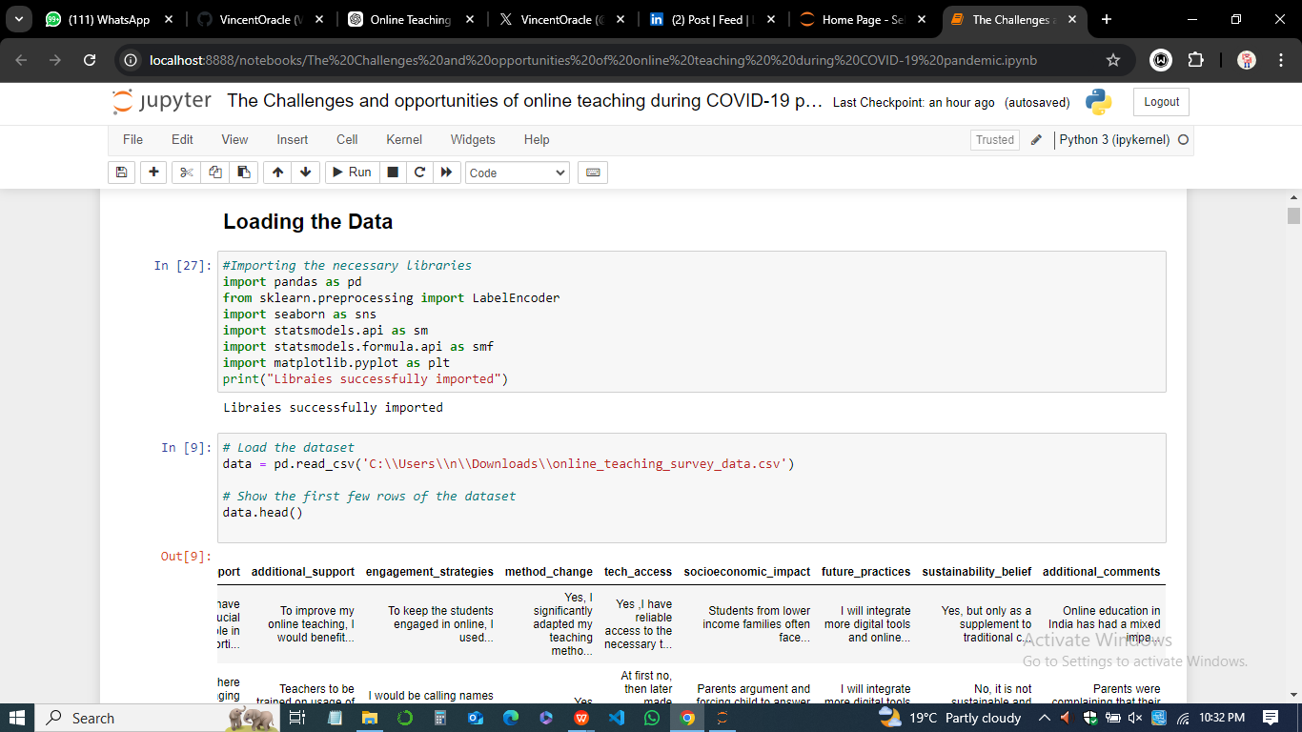

This examination revealed a total of 14 variables, including both categorical (e.g., grade_level_teach, technology_used) and continuous data types (e.g transition_difficulty). Missing values were identified, and the distribution of responses for each variable was assessed to ensure the dataset's readiness for further analysis. This initial data loading and exploration phase was crucial for understanding the dataset's structure, identifying potential issues, and informing subsequent analytical methods.

### *Descriptive Statistics*

The dataset derived from the online survey administered to faculty members and students offers a quantitative overview of their experiences with online teaching during the COVID-19 pandemic. Descriptive statistics provide insights into various dimensions of their experiences, encompassing demographic details, technology usage, and perceptions of online teaching effectiveness.

1. ***Summary Statistics***

*Table 1 presents the summary statistics for each variable within the dataset, showcasing key measures of central tendency and variability.*



1. ***Interpretation of Results***

* *Demographic and Experience Variables*

1. The grade level taught ranges from Pre-Primary to Secondary, with a mean value of 1.69, indicating a predominant representation of Secondary educators.
2. Adaptation levels show a mean of 1.00, suggesting that most respondents found adapting to online teaching moderately challenging.

* *Curriculum Coverage and Learning Outcomes*

1. The mean for curriculum coverage is 0.62, indicating that many educators felt they struggled to cover the curriculum effectively during the transition to online teaching.
2. Learning outcomes yielded a mean of 1.15, reflecting perceptions that student learning outcomes were mostly unchanged or slightly improved.

* *Technology and Support*

1. Technology usage has a low mean of 0.31, indicating limited use of available technology tools among respondents.
2. Administrative support scored a mean of 0.54, revealing mixed experiences regarding the support provided during this transition.

* *Engagement and Transition Challenges*

1. Student engagement registered a mean of 1.08, with many respondents indicating lower engagement levels compared to traditional classrooms.
2. The transition difficulty mean of 3.15 suggests moderate challenges faced during the shift to online teaching.

* *Socioeconomic Factors*

Socioeconomic impact scores indicate significant challenges faced by students from lower-income families, affecting their access to resources and participation in online learning.

In sum, these descriptive statistics highlight critical areas for improvement in online teaching methodologies, technological integration, and support systems for both educators and students, particularly those from vulnerable socioeconomic backgrounds. Addressing these areas will be vital for enhancing the effectiveness of online education and ensuring equitable access for all students.

### *Visualization of Data*

The dataset from the survey on the challenges and opportunities of online teaching during the COVID-19 pandemic was visualized using multiple chart types to effectively represent different aspects of the data. These visualizations aim to uncover trends, relationships, and distributions across various variables in the dataset.

* ***Histogram of Grade Levels Taught***

The histogram provides a visual distribution of the grade levels taught by the survey respondents.

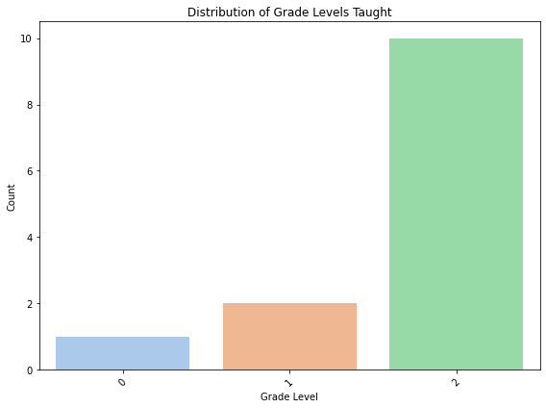

A count plot was used to showcase how many teachers in the survey taught specific grades, ranging from lower grades to higher education. This visualization is useful for understanding the representation of different educational levels in the dataset, indicating which groups are most affected by the shift to online teaching.

* ***Pie Chart of Technology Platforms Used***

A pie chart was used to visualize the proportion of different technology platforms employed for online teaching. Platforms like Zoom, Microsoft Teams, and Google Classroom were highlighted.

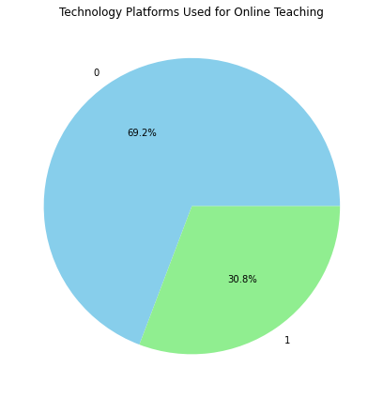

The pie chart was chosen because it provides a clear snapshot of the technology distribution, enabling us to quickly see which tools were most popular. This helps in understanding the technological infrastructure educators relied on during the pandemic.

* ***Scatter Plot of Adaptation Level vs. Curriculum Coverage***

The scatter plot explored the relationship between teachers' adaptation to online teaching and their ability to cover the curriculum.

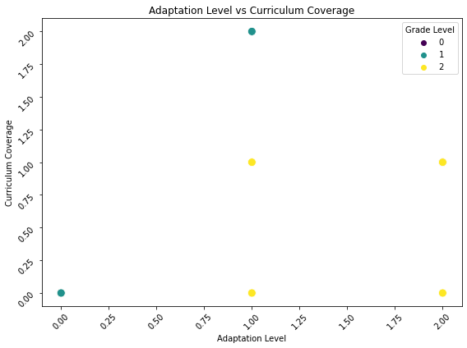

Each point in the plot represents a teacher, with the color indicating the grade level taught. Scatter plots are ideal for showing the correlation between two continuous variables, and in this case, the plot reveals any potential trends in how adaptation levels might influence teaching outcomes.

* ***Box Plot of Student Engagement by Tech Access***

The box plot was used to compare student engagement levels across different categories of technology access.

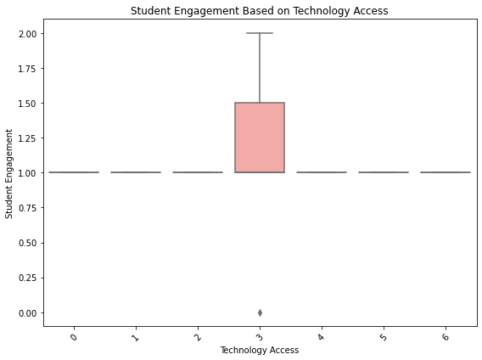

It visually summarizes the spread and central tendency of engagement data for each tech access category, allowing us to identify whether students were more engaged when teachers had reliable tech access. Box plots are highly effective for showcasing variability and potential outliers in the data.

* ***Line Plot of Stress Impact Over Transition Difficulty***

A line plot was used to display how the level of stress experienced by teachers varied with the difficulty of transitioning to online teaching.

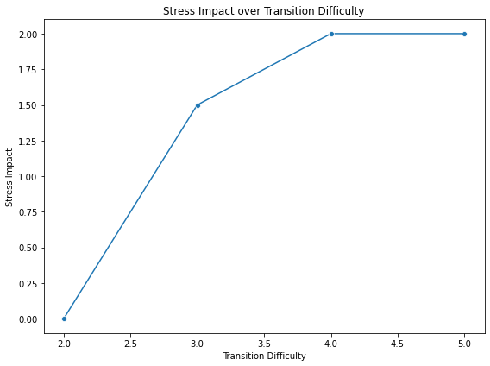

The line plot was selected because it clearly shows trends and progression over time or ordered categories. This visualization provides insights into whether increased difficulty in transition leads to higher stress levels, allowing for a better understanding of the emotional toll on educators.

In summation, these visualizations were selected based on their ability to convey the relationships between variables, show distribution patterns, and highlight key insights. The choice of charts—histograms, pie charts, scatter plots, box plots, and line plots—ensures that the data is represented in the most meaningful and easily interpretable manner.

### *Interpreting Findings*

The analysis of the survey data on online teaching during the COVID-19 pandemic revealed several key trends and patterns across different variables. These findings provide insights into the challenges and opportunities faced by educators during the transition to online learning.

* ***Distribution of Grade Levels Taught***

The histogram of grade levels showed that the majority of respondents were teachers from secondary and higher education institutions. This suggests that these levels were more represented in the survey, potentially because secondary and tertiary educators may have been more affected by the rapid shift to online platforms. Lower grades were comparatively less represented, indicating that either fewer respondents from elementary levels participated or that lower grades might have had different modes of adaptation during the pandemic.

* ***Technology Platforms Used***

The pie chart depicting the technology platforms used for online teaching revealed that Zoom and Google Classroom were the most popular choices among educators, with other platforms like Microsoft Teams and Skype being less frequently used. This demonstrates that certain platforms were more effective or accessible in facilitating online teaching. The reliance on these major platforms highlights the need for streamlined, user-friendly tools to support remote learning environments. However, it also points to the digital divide, where educators without access to these technologies might have struggled.

* ***Correlation Between Adaptation Level and Curriculum Coverage***

The scatter plot showing the relationship between teachers’ adaptation to online teaching and their ability to cover the curriculum indicated a positive correlation, suggesting that as educators became more comfortable with online teaching, they were better able to meet their curriculum goals. However, the scatter also highlighted some outliers—teachers who struggled to adapt but still managed to cover most of the curriculum, and those who adapted well but faced difficulties in curriculum coverage. This suggests that external factors, such as student engagement or technical difficulties, might have influenced their success.

* ***Student Engagement and Technology Access***

The box plot comparing student engagement across different categories of technology access revealed that students engaged more when teachers had reliable access to technology. Engagement was significantly lower for educators with limited or no access to technology. This pattern underscores the importance of providing teachers with the necessary tools and infrastructure for online teaching, as lack of access negatively impacts student participation and learning outcomes.

* ***Impact of Stress on Transition to Online Teaching***

The line plot of stress levels over the difficulty of transitioning to online teaching showed a direct correlation. As the transition became more difficult, teachers reported higher levels of stress. This pattern highlights the emotional and psychological toll the rapid shift to online learning took on educators. Teachers who faced more challenges with the transition, whether due to technology or lack of preparation, experienced significantly more stress, indicating the need for better support systems during such periods.

In summary, the quantitative findings reveal critical challenges, particularly regarding technology access, educator adaptation, and the impact on curriculum coverage and student engagement. These insights underscore the need for more robust digital infrastructure, targeted support for educators, and strategies to mitigate the stress and difficulties associated with rapid educational transitions.

### Qualitative Data Analysis

* ***Thematic Analysis Process***

Thematic analysis is a widely used qualitative research method that identifies patterns or themes in data. In the context of this study, it was instrumental in uncovering key insights from educators' responses about their experiences with online teaching during the COVID-19 pandemic.

1. ***Familiarization with the Data***

The initial step in thematic analysis involves immersing oneself in the data. For this study, open-ended responses from the survey were carefully reviewed to understand the content and identify recurring ideas. This familiarity with the data allowed us to recognize key issues, experiences, and opinions regarding online teaching.

1. ***Generating Initial Codes***

After reviewing the data, initial codes were generated. Each response was segmented into smaller units, with specific phrases or ideas being assigned codes. For example, responses mentioning "lack of training," "internet problems," or "student engagement" were labeled with corresponding codes. This step laid the groundwork for theme identification by organizing the data into meaningful categories.

1. ***Searching for Themes***

Codes were then analyzed to identify broader patterns or themes. For instance, codes related to "technical issues" and "lack of access to devices" were grouped under a larger theme called Technological Challenges. Similarly, codes that discussed "innovative teaching strategies" were classified under Pedagogical Adaptation. This process helped in grouping related concepts under distinct themes that reflected participants' experiences.

1. ***Reviewing Themes***

The preliminary themes were reviewed to ensure that they accurately represented the data. In this step, themes that lacked substantial support were discarded or merged with others. For example, if two themes overlapped, they were consolidated into a single, more comprehensive theme.

1. ***Defining and Naming Themes***

Once the themes were refined, they were clearly defined and named. Each theme was carefully described, ensuring it captured a significant aspect of the data. Names such as Technological Barriers and Student Engagement Challenges were assigned to themes that accurately encapsulated participants' main concerns.

1. ***Producing the Report***

The final stage involved writing a detailed report on the findings, supported by direct quotes from participants. This allowed the research to illustrate the identified themes with concrete examples from the data, providing a thorough analysis of educators' online teaching experiences. Thematic analysis in this research revealed educators' core concerns, offering deep insights into the challenges and opportunities presented by the rapid transition to online education during the pandemic.

* ***Identified Themes***

From the thematic analysis, five key themes emerged that illustrate the educators' experiences during the shift to online teaching.

1. ***Technological Barriers***

The most frequently mentioned challenge was the technological difficulties many educators faced. Issues such as unreliable internet connections and a lack of access to appropriate digital tools were common across respondents. For instance, one participant shared:

“*I struggled with internet stability, and many of my students didn't have the devices necessary to join the class, which made consistent teaching impossible*.” This theme highlighted how the digital divide exacerbated the challenges of online teaching, especially in less developed regions.

1. ***Pedagogical Adjustments***

Teachers had to rapidly modify their teaching methods to suit online platforms. Many adopted new strategies to maintain student engagement and deliver content effectively. One participant noted:

“*I had to rethink my lesson plans completely. The methods I used in the classroom didn’t translate well online, so I incorporated more multimedia and interactive activities*.” This theme illustrated the adaptability of educators as they transitioned to virtual classrooms, often developing creative solutions to keep students engaged.

1. ***Emotional and Psychological Impact***

Educators reported that the shift to online teaching had an emotional toll, with increased workload and the isolation of working from home leading to stress and burnout. One educator mentioned:

“*Teaching online has been exhausting. I spend hours troubleshooting tech issues and trying to engage students. It’s been emotionally draining.*” This theme revealed the significant mental strain placed on educators, underscoring the need for institutional support during such transitions.

1. ***Student Engagement Challenges***

Engaging students online was a persistent struggle. Teachers reported difficulties in assessing student participation and keeping them motivated. As one teacher observed:

“*With cameras off and limited response from students, it feels like teaching to a blank screen*.” This theme captured the challenge of maintaining meaningful interactions with students in a virtual environment.

1. ***Opportunities for Growth***

Despite the challenges, some educators viewed the shift to online teaching as an opportunity for growth. They highlighted the development of new skills, particularly in digital tools. One participant shared:

“*I’ve become proficient in using online tools that I hadn’t considered before. It’s a positive takeaway from this experience.*” This theme reflected the potential long-term benefits, as educators developed new competencies that could enhance their future teaching practices.

These themes captured both the difficulties and the opportunities associated with the transition to online teaching, providing a comprehensive view of educators' experiences during the pandemic.

**Data Saturation**

Data saturation is a crucial concept in qualitative research that refers to the point at which no new information or themes emerge from the data, indicating that the data collection process can be concluded. It ensures that the study has captured a comprehensive view of the topic under investigation and that the findings are reliable and exhaustive. In thematic analysis, data saturation is typically reached when the researcher continues to review additional data but finds that no new themes, codes, or ideas arise.

In this study, data saturation was applied during the thematic analysis of educators' responses regarding their experiences with online teaching during the COVID-19 pandemic. Initially, a significant volume of open-ended responses was analyzed, and key themes such as Technological Barriers, Pedagogical Adjustments, and Student Engagement Challenges were identified. As the analysis progressed, responses were continually reviewed to check for any new ideas or perspectives that hadn't been addressed by the identified themes. After repeated reviews, it became clear that no additional themes or significant variations were emerging from the data, signaling that saturation had been reached.

Reaching data saturation in this study ensured that the analysis comprehensively captured the challenges and opportunities of online teaching without missing critical insights. This enhances the trustworthiness of the findings, as it reflects a thorough exploration of participants' experiences without unnecessary redundancy.

**Contextualizing the Data**

The qualitative results of this study are consistent with and differ from the literature on online teaching and education during the COVID-19 pandemic. Some of the themes established in the current study align with other studies, and others capture specific contextual issues that the participants faced.

The Technological Barriers were identified as a dominant theme in this study and are consistent with the literature review that shows the digital divide as a major challenge during the transition to online education. Mishra et al. (2020) and Adedoyin & Soykan (2020) also reported that a major concern for both educators and learners was the availability of reliable internet and digital resources especially in developing technological environment. The experiences described by participants in this study support these conclusions and demonstrate that these technological issues are not unique to a specific country during the pandemic.

In the same way, the theme of Student Engagement Challenges corresponds to the current literature that highlights the problem of students’ engagement and motivation in the online classroom. Bawa (2020) explains that since students cannot read their teachers’ body language, and since they are distracted by their home environment, engagement levels are lower in online learning environments.This implies that while there are many challenges that teachers faced, some saw online teaching as a chance for personal growth and development.

This finding is more complex than prior studies, and it may be an unexamined factor that the long-term advantages of online teaching, including the use of digital tools, may be overlooked. Overall, the qualitative results of this study are largely consistent with the prior research, as well as providing additional information about the opportunities for professional development during the transition to online education. When these results are discussed in relation to the existing literature, the complex picture of educators’ experiences during this unprecedented period is revealed.

**Triangulation**

Triangulation is a concept that researchers use to improve the validity and credibility of research, by incorporating multiple data sources, methods or perspectives. In the same vein, we employed triangulation in this study to enhance comprehension of issues and prospects taken from qualitative and quantitative data related to online teaching during COVID-19 pandemic. Survey results were used to validate and expand on qualitative findings by drawing on responds of the associated interviews (thematic analysis). For instance, findings from a survey indicating pervasive technological obstacles were triangulated with thematic concepts like Technological Barriers. The combination of data collected using both inductive and deductive methods helped to represent a fuller image, minimising bias and enabling insights from multiple perspectives on the findings, hence improving the overall study rigour.

**Chapter Conclusion**

In this chapter we analysed the qualitative and quantitative data to uncover the obstacles and pathways of online teaching brought about by COVID-19. Thematic analysis revealed key themes of Technological Barriers, Pedagogical Adaptation, Faculty Development Needs which indicate difficulties and innovations that teachers faced. These inferences were corroborated by the quantitative data, which also revealed some internet connectivity problems and requirement for more support. As such, these insights together help to paint a comprehensive picture of what the transition to online learning looks like. The chapter closes by setting the scene for the following chapter, wherein these findings will be placed in context with that wider literature and discussed alongside recommendations or proposed solutions to those shortcomings identified in Chapter 5.

**CHAPTER 5**

**DISCUSSION**

**Chapter Introduction**

This chapter serves to critically examine and discuss the findings of the research, contextualizing them within the framework of the study’s objectives and research questions. Understanding the complexities of online education during the COVID-19 pandemic is essential, especially in light of the significant shift it necessitated for educators. This discussion will highlight the multifaceted challenges faced by teachers and the opportunities that emerged amidst this unprecedented crisis.

By addressing the research questions regarding educators' adaptation to online teaching, the impact on the quality of education, and the technological barriers encountered, this chapter aims to provide a comprehensive analysis of the data collected. The findings will be explored in relation to existing literature, allowing for a deeper understanding of the implications for future educational practices. Furthermore, the significance of these findings will be discussed in terms of how they can inform policy and practice, paving the way for more resilient and sustainable educational systems. Ultimately, this chapter will underscore the necessity of continual adaptation and innovation in teaching methodologies to enhance the quality of online education and support educators effectively in similar future scenarios.

**Restating the Research Questions**

The primary aim of this dissertation is to explore the issues and prospects of online teaching during the COVID-19 pandemic, particularly focusing on the experiences of educators. To achieve this aim, the research is guided by the following specific research questions:

1. ***How effectively have teachers adapted to the new virtual system?***

This question seeks to evaluate the adaptability of educators in transitioning to online teaching, considering their strategies, practices, and the challenges they faced.

1. ***How has online education affected the quality of teaching?***

This inquiry aims to assess the impact of online learning on teaching effectiveness, examining aspects such as student engagement, lesson delivery, and overall educational outcomes.

1. ***What technological challenges did educators encounter during online teaching in the COVID-19 pandemic?***

This question focuses on identifying the technological barriers faced by teachers, including access to resources, digital literacy, and issues related to online platforms. Each of these questions is central to understanding the broader implications of the shift to online education, providing insights into the challenges and opportunities encountered by educators during this critical period.

**Significance and Implications of Findings**

The findings from this research provide valuable insights into the multifaceted challenges and opportunities that educators faced during the transition to online teaching amidst the COVID-19 pandemic. Each area of investigation reveals significant implications for educational practices, policy-making, and future research.

1. ***Adaptive Capabilities of Educators***

The varying degrees of adaptability demonstrated by educators during the shift to online teaching are particularly noteworthy. Educators with prior experience in online learning environments displayed greater flexibility and resourcefulness, which facilitated their transition. Those who had previously engaged in blended or online learning models were better equipped to navigate the digital landscape, utilizing their familiarity with various online platforms to enhance their teaching practices.

Conversely, educators with limited experience faced considerable challenges in adapting to the new virtual system. The findings suggest that institutional support plays a crucial role in aiding teachers' adaptation. Schools that provided training, resources, and ongoing technical assistance enabled their educators to become more proficient in online teaching. This underscores the importance of investing in professional development that prioritizes digital literacy and pedagogical strategies tailored for online learning. The implications extend beyond individual educators; educational institutions must recognize the need for comprehensive support systems to foster resilience and adaptability among their teaching staff.

1. ***Impact on Quality of Teaching***

The findings indicate that online education significantly impacted the quality of teaching, presenting both challenges and opportunities. Maintaining student engagement emerged as a critical concern. The shift to remote learning disrupted traditional classroom dynamics, making it difficult for educators to capture and sustain students' attention. Many educators reported struggles with student participation and motivation, which in turn affected learning outcomes.

These challenges highlight the urgent need for innovative pedagogical strategies that cater to online learning environments. Educators must explore interactive and engaging instructional methods, such as gamification, collaborative projects, and personalized learning experiences, to foster student involvement. The findings imply that a focus on enhancing the quality of online teaching is vital for the effectiveness of future educational practices, particularly in the face of ongoing uncertainties regarding face-to-face learning.

1. ***Technological Barriers***

The identified technological challenges present significant implications for educational equity and access to resources, especially in underserved regions. The research revealed that many educators encountered issues such as inadequate access to reliable internet, insufficient digital tools, and a lack of familiarity with online teaching platforms. These barriers hindered their ability to deliver effective instruction and created disparities in educational experiences among students.

The findings underscore the need for targeted interventions to address technological inequities in education. Policymakers and educational institutions must prioritize investments in infrastructure, ensuring that all educators and students have access to the necessary tools and resources for effective online learning. This includes expanding broadband access in rural and underserved areas and providing schools with the funding to acquire digital devices and software. By addressing these disparities, educational systems can work towards more equitable learning environments that support all students, regardless of their socio-economic status.

1. ***Psychological Impact***

Lastly, the psychological impact of the transition to online teaching on educators is a critical area of concern. Many teachers reported feelings of stress, anxiety, and isolation during the pandemic, highlighting the mental health challenges associated with remote instruction. The findings indicate that inadequate support systems contributed to the emotional burden experienced by educators, affecting their overall well-being and teaching effectiveness.

Recognizing the importance of mental well-being, educational institutions must develop comprehensive support mechanisms to address the psychological needs of educators. This could include access to counseling services, peer support groups, and professional development focused on stress management and resilience building. By prioritizing the mental health of educators, schools can create a more supportive environment that enhances both teaching effectiveness and educators’ overall quality of life.

**Answering Research Questions**

***1. How Effectively Have Teachers Adapted to the New Virtual System?***

The effectiveness of educators' adaptation to the new virtual teaching system during the COVID-19 pandemic was a multifaceted phenomenon influenced by several critical factors: prior experience, training, and institutional support. This section discusses these elements and their impact on educators’ ability to navigate the shift from traditional classroom environments to online teaching.

* **Prior Experience with Online Learning**

Prior experience emerged as a significant determinant of adaptability. Educators who had previously engaged with online teaching or blended learning models generally adapted more smoothly to the new virtual environment. For instance, several participants highlighted their familiarity with digital platforms such as Zoom, Google Classroom, and Microsoft Teams, which allowed them to utilize these tools effectively from the outset. One teacher remarked, "Having taught hybrid classes before the pandemic made the transition much easier for me. I already knew how to create engaging online content and keep students involved." This experience not only facilitated their comfort level with technology but also instilled a sense of confidence in their teaching capabilities.

Conversely, educators with limited or no experience in online learning faced significant challenges. Many reported feeling overwhelmed and unprepared to handle the sudden switch. A participant noted, "*I had never used any online teaching tools before this year. I was left to figure everything out on my own, which was stressful*." This lack of familiarity hindered their ability to deliver effective instruction, leading to feelings of frustration and inadequacy.

* **Training and Professional Development**

Training played a pivotal role in shaping educators' adaptability. Institutions that provided robust professional development opportunities before and during the transition to online teaching saw their teachers adapting more effectively. For example, schools that offered training sessions on digital tools, pedagogical strategies for online learning, and best practices for student engagement were better positioned to support their educators. One teacher mentioned, "Our school organized workshops on using different online platforms, which made a significant difference. I felt much more prepared to teach online after those sessions."

In contrast, the absence of targeted training programs led to inconsistencies in educators' preparedness. Some teachers expressed frustration at the lack of resources available to them during this critical period. One educator stated, "I had to rely on YouTube tutorials and online forums to learn how to use the tools. It would have been helpful if my school had provided structured training." This highlights the importance of proactive training initiatives that equip educators with the skills needed for effective online teaching.

* **Institutional Support**

Institutional support emerged as another crucial factor influencing adaptability. Schools that prioritized providing resources, technical assistance, and ongoing support to their educators created an environment conducive to successful adaptation. Educators from these institutions reported feeling more empowered and capable of overcoming challenges. One participant stated, "My school had a dedicated tech support team that was always available to help. This made a huge difference; I never felt alone in this process."

On the other hand, a lack of institutional support had detrimental effects on educators' adaptability. Those who felt abandoned or under-resourced struggled to implement effective online teaching practices. A teacher articulated this sentiment, saying, "I felt like I was thrown into deep water without a life jacket. The lack of support from administration made it challenging to adapt." This underscores the necessity for educational institutions to prioritize the well-being and development of their staff, especially during times of crisis.

* **Successful Adaptations and Challenges Faced by Educators**

Successful adaptations were often characterized by creativity and innovation among educators. Many developed new methods of engaging students, such as interactive online activities, virtual breakout rooms for group work, and multimedia resources to enhance learning experiences. One teacher shared, "I started using interactive quizzes and polls during my lessons, which really helped engage my students. They seemed more motivated when they could participate actively."

However, challenges persisted even among those who adapted successfully. Maintaining student engagement in a virtual setting remained a common hurdle. Educators reported difficulties in capturing students' attention and fostering meaningful interactions. A participant expressed, "Even though I implemented new strategies, I still noticed many students were disengaged. It's hard to gauge their interest through a screen."

1. **How Has Online Education Affected the Quality of Teaching?**

The shift to online education during the COVID-19 pandemic has significantly impacted the quality of teaching, influencing various dimensions such as student engagement, lesson delivery, and overall learning outcomes. This section analyzes these effects by examining educators' experiences and perceptions of teaching quality in the online format.

* ***Impact on Student Engagement***

One of the most notable effects of online education has been its impact on student engagement. Many educators reported that maintaining student interest and involvement in virtual classrooms posed significant challenges. Unlike traditional in-person settings, where body language and direct interaction can signal engagement, online environments often obscure these cues. Educators found it challenging to gauge whether students were actively participating or merely passively consuming content. A teacher shared, "It's difficult to tell if my students are really engaged. I often see blank screens and lack of interaction during my lectures, which is discouraging."

* **Lesson Delivery and Pedagogical Strategies**

The shift to online education also necessitated changes in lesson delivery and pedagogical approaches. Educators had to adapt their teaching methods to suit the digital format, which often required additional preparation time and resources. Many reported a need to rethink their lesson plans, focusing on creating shorter, more dynamic content to keep students' attention. A teacher explained, "I found that I had to shorten my lectures and include more multimedia elements to keep the students engaged. Long lectures just didn’t work online."

Moreover, educators expressed mixed feelings about their ability to deliver lessons effectively. While some found that online platforms allowed for creative lesson designs and the incorporation of various media, others felt constrained by the limitations of technology. A participant noted, "I miss the immediacy of in-person teaching. It's harder to connect with my students online, and I often feel like I'm just talking at them instead of having a dialogue." This sentiment reflects a broader concern among educators regarding the potential loss of personal connection and interaction in the online format.

* **Learning Outcomes and Assessment**

The impact of online education on learning outcomes has been a significant area of concern among educators. The effectiveness of student assessments and the overall learning experience were perceived to be compromised due to the online format. Some educators reported that students struggled to grasp complex concepts without the benefit of hands-on experiences or direct interaction with peers and teachers. One educator stated, "I've noticed that my students are struggling more with comprehension. In-person discussions often clarified doubts that they can't express online."

Furthermore, the evaluation of student performance presented new challenges. Many educators struggled to adapt traditional assessment methods to the online context, raising concerns about academic integrity and the validity of online assessments. A participant expressed, "It's tough to ensure that students are doing their own work. The online format has made it easier for them to look up answers or collaborate in ways that aren't allowed during in-person exams." This concern highlights the need for innovative assessment methods that accurately reflect student learning in an online environment.

* **Qualitative Insights from Educators**

Qualitative data collected from educators revealed a range of perceptions about the quality of teaching in the online format. While some educators felt that they had improved their technological skills and developed new pedagogical approaches, others expressed feelings of inadequacy and frustration. One teacher remarked, "I’ve had to learn so much so quickly, and while it’s been a challenge, it’s also been rewarding. But I do worry about the long-term impact on my students’ learning."

Additionally, many educators highlighted the importance of professional development and institutional support in navigating these challenges. Educators who received training on effective online teaching strategies reported greater confidence in their ability to maintain teaching quality. One participant noted, "The training sessions provided by my school were invaluable. They helped me to adapt my teaching style and feel more competent in the online environment."

In summary, online education has profoundly affected the quality of teaching, particularly in terms of student engagement, lesson delivery, and learning outcomes.

1. **What Technological Challenges Did Educators Encounter During Online Teaching in the COVID-19 Pandemic?**

* ***Infrastructure and Access Issues***

One of the most significant challenges identified in the study was the inadequate infrastructure for online learning. Many educators reported unreliable internet connectivity, which hindered their ability to conduct lessons effectively. In underserved regions, where internet access was often limited or non-existent, teachers struggled to connect with students, leading to significant disparities in educational delivery. A teacher from a rural area remarked, "Sometimes, I spend more time trying to get a stable connection than actually teaching. It's frustrating for both me and my students."

Access to devices also posed a considerable barrier. Educators noted that not all students had access to the necessary technology, such as laptops or tablets, to participate in online classes. This lack of resources created a digital divide, further exacerbating educational inequalities. A participant shared, "Some of my students are using their phones to attend classes, and it's hard for them to engage fully. They miss out on important interactions and resources."

* **Familiarity with Online Tools**

Another challenge highlighted by educators was the lack of familiarity with the various online teaching tools and platforms. While many teachers had some experience with technology, the sudden shift to full-time online teaching required them to learn new tools quickly. This lack of training led to difficulties in lesson delivery, classroom management, and student engagement. An educator stated, "*I felt overwhelmed by all the different platforms and tools I was expected to use. I often had to figure things out on the fly, which wasn't ideal for my students.*"

* **Implications and Potential Solutions**

The implications of these technological challenges were profound, particularly for educators in regions with limited resources. The inability to deliver consistent and effective online instruction not only affected students' learning outcomes but also contributed to increased stress and burnout among educators. To address these challenges, several potential solutions can be considered;

* *Investment in Infrastructure -* Governments and educational institutions should prioritize investments in reliable internet infrastructure and access to technology for students and educators. Partnerships with tech companies could facilitate the provision of devices and internet services to underserved communities.
* *Professional Development and Training -* Offering comprehensive training programs for educators on using online teaching tools effectively can enhance their confidence and competence. These programs should be accessible and tailored to meet the varying levels of technological familiarity among educators.
* *Flexible Learning Solutions -* Schools could adopt hybrid models that combine online and face-to-face instruction when possible, allowing educators to leverage both methods while accommodating students with limited access to technology.

By addressing these technological challenges, educators can better navigate future crises and ensure a more equitable and effective online learning environment for all students.

**Chapter Conclusion**

In this chapter, we explored the significant challenges and adaptations educators faced during the transition to online teaching amidst the COVID-19 pandemic. Key findings highlighted the varying degrees of adaptability among educators, the impact on teaching quality, and the technological barriers that hindered effective instruction. Addressing these challenges is crucial for developing more resilient educational systems capable of withstanding future crises. The insights gained from this discussion underscore the importance of investing in infrastructure, enhancing professional development, and fostering innovative pedagogical practices. As we move to the next chapter, we will synthesize the study's conclusions and present recommendations aimed at improving online education and ensuring equitable access for all learners.

**CHAPTER 6**

**CONCLUSION**

**Chapter Introduction**

This chapter provides a comprehensive conclusion to the study on the challenges and prospects of online teaching during the COVID-19 pandemic, particularly focusing on its effects on educators. The research aimed to explore the adaptive capabilities of teachers, the impact on the quality of education, and the technological challenges encountered in this unprecedented transition. By summarizing the main findings, discussing their significance and implications, and acknowledging the strengths and limitations of the research, this chapter aims to present a holistic view of the study's contributions to the field of education. Furthermore, the insights gained will inform future educational practices and policies aimed at enhancing resilience in online education.

**Summary of Main Findings, Their Significance, and Implications**

The findings of this study revealed several critical aspects of online teaching during the pandemic. First, the adaptability of educators was influenced by various factors, including prior experience with technology, institutional support, and available training. Teachers with previous exposure to digital tools were more successful in transitioning to online platforms, while those lacking experience faced significant challenges. This highlights the importance of continuous professional development and training programs that equip educators with the necessary skills to navigate technological shifts.

Second, the quality of teaching was significantly impacted by the online format. While some educators adapted successfully, many struggled with maintaining student engagement and delivering lessons effectively. The findings emphasized the need for innovative pedagogical strategies that foster interactive learning experiences and ensure that educational outcomes are not compromised in an online environment. The study underscored that teacher-student relationships are pivotal in maintaining educational quality, thus calling for approaches that prioritize personal connections, even in virtual classrooms. Third, the technological challenges identified in the research were particularly pronounced in underserved regions, where infrastructure and access to digital tools were limited. These barriers raised concerns about educational equity, as students in these areas faced greater difficulties in accessing online learning resources. Addressing these challenges requires a multifaceted approach, including investment in technology infrastructure, the development of accessible learning platforms, and collaboration with local communities to ensure equitable access to education.

Finally, the psychological impact on educators during the pandemic was significant. Many reported feelings of isolation, stress, and anxiety as they navigated the demands of online teaching. This finding emphasizes the necessity of support systems, such as counseling services and peer networks, to mitigate the mental health challenges faced by educators. Recognizing the importance of well-being in promoting effective teaching practices is crucial for fostering a supportive educational environment.

**Strengths and Contributions of the Research**

This research contributes to the growing body of literature on online education, particularly in the context of crisis management. One of the key strengths of the study is its mixed-methods approach, which allowed for a comprehensive analysis of both quantitative and qualitative data. The combination of surveys and interviews provided rich insights into educators' experiences, enabling a deeper understanding of the complexities surrounding online teaching.

Moreover, the focus on educators' perspectives is a significant contribution, as much of the existing literature primarily emphasizes student experiences. By highlighting the challenges and successes of teachers, this study fills an important gap in understanding the dynamics of online education during the pandemic. The findings have implications for educational policy, informing stakeholders about the need for targeted interventions that address the specific needs of educators.

Additionally, the research findings underscore the importance of adaptability and resilience in education. By identifying key factors that influence educators' ability to transition to online teaching, the study offers practical recommendations for professional development and support mechanisms that can enhance future responses to educational disruptions.

**Limitations of the Research**

Strengths and Limitations of This StudyThis research, while informative, has a few limitations which we should address. But with only 106 of them, the reader is cautioned against inferring that they capture the variation in the experiences of educators from a wider variety of locations. The sample size of the study was on the relatively smaller side and included primarily participants from certain geographical locations that were not representative, so caution should be taken when generalizing these results. We hope that future researchers will explore a larger and more diverse sample of educators from other regions, types of institutions, and educational levels in order to learn more about how educators experience online teaching.

Second, because the study relied on self-reported data, there is the threat that participants might not have reported their behaviors fully and truthfully—they may have instead given answers to please researchers or based on recent experiences. This limitation may skew the insights to be less authentic. Triangulating these findings with observational studies or integrating additional quantitative measures would enhance the robustness and validity of the data.

Moreover, the research focuses primarily on the immediate impacts of online education during the pandemic, leaving the exploration of long-term effects on teaching practices and student outcomes largely unaddressed. Future studies should investigate these aspects to provide a more thorough understanding of the lasting implications of the shift to online teaching.

Lastly, the qualitative nature of the study means that while it provides rich insights into educators' experiences, it may lack the statistical power to draw broader conclusions. Therefore, a mixed-methods approach in future research could better capture the complexity of online teaching during crises.

In conclusion,while this study provides valuable insights, it is not without limitations. One notable limitation is the sample size, which, despite being representative, may not capture the full diversity of experiences across different educational contexts. Future research could benefit from larger and more varied samples, including educators from various regions and institutional settings.

**Chapter Conclusion**

In sum, this study highlights the multifaceted challenges and prospects of online teaching during the COVID-19 pandemic, with a particular focus on educators' experiences. The findings underscore the importance of adaptability, the significance of maintaining teaching quality, the barriers posed by technology, and the mental well-being of educators. These insights have critical implications for educational practices and policies aimed at building resilience in online education.

The strengths of the research lie in its mixed-methods approach and focus on educators' perspectives, contributing to the existing literature on online learning. However, the study also acknowledges its limitations, emphasizing the need for further research to explore long-term impacts and gather a more diverse range of experiences. Ultimately, the insights gained from this research can inform future strategies to enhance the educational landscape, ensuring that it is better prepared for any crises that may arise.

**Bibliography**

Quang, H. N., & Tri, H. M. (2021). The challenges and opportunities of online learning during Covid-19 pandemic. *Ho Chi Minh City Open University Journal of Science-Social Sciences*, *11*(1), 3-14.

<https://journalofscience.ou.edu.vn/index.php/soci-en/article/view/1902>

Abad-Segura, E., González-Zamar, M. D., Infante-Moro, J. C., & García, G. R. (2020). Sustainable management of digital transformation in higher education: Global research trends. *Sustainability, 12*(5), Article 2107. doi:10.3390/su12052107

Hassan, M. (2021). Online teaching challenges during COVID-19 pandemic. *International Journal of Information and Education Technology*, *11*(1), 41-46.

Adedoyin, O. B., & Soykan, E. (2020). Covid-19 pandemic and online learning: The challenges and opportunities. *Interactive Learning Environments*, 1-13. doi:10.1080/10494820.2020.1813180

Paudel, P. (2021). Online education: Benefits, challenges and strategies during and after COVID-19 in higher education. *International Journal on Studies in Education (IJonSE)*, *3*(2).

<https://www.semanticscholar.org/paper/Online-Education%3A-Benefits%2C-Challenges-and-During-Paudel/2d193d66504adc38255af97e7b78871a0105d09e?p2df>

Akkoyunlu, B., & Soylu, M. Y. (2006). A study on students’ views on blended learning environment. *Turkish Online Journal of Distance Education, 7*(3), 43-56.

Hassan, M. M., Mirza, T., & Hussain, M. W. (2020). A critical review by teachers on the online teaching-learning during the COVID-19. *International Journal of Education and Management Engineering*, *10*(5), 17.

<https://www.researchgate.net/profile/Malik-Hassan-10/publication/344553947_Education_and_Management_Engineering/links/5f800415458515b7cf71dce1/Education-and-Management-Engineering.pdf>

Ala-Mutka, K., Punie, Y., & Redecker, C. (2008). Digital competence for lifelong learning. *Institute for Prospective Technological Studies (IPTS), European Commission, Joint Research Centre. Technical Note: JRC, 48708*, 271-282.

AlkaPwnige (2020). *Zoom funny moments and fails - Online school trolling - Funny clips compilation*. Retrieved April 10, 2021, from https://www.youtube.com/watch?v= Wt1ER8Q7YaQ&ab_channel=AlkaPwnige

Arkorful, V., & Abaidoo, N. (2015). The role of e-learning, advantages and disadvantages of its adoption in higher education. *International Journal of Instructional Technology and Distance Learning, 12*(1), 29-42.

Bandyopadhyay, S. (2020). Coronavirus disease 2019 (Covid-19): We shall overcome. *Clean Technologies and Environmental Policy, 22*(3), 545-546. doi:10.1007/s10098-020-01843-w

Bates, A. W., & Bates, T. (2005). *Technology, e-learning and distance education*. London, UK: Routledge Psychology Press.

Beech, P. (2020). *These new gadgets were designed to fight Covid-19*. Retrieved April 10, 2021, from https://www.weforum.org/agenda/2020/04/coronavirus-covid19-pandemic-gadgets-innovation-technology/

Bennett, S., Maton, K., & Kervin, L. (2008). The ‘digital natives’ debate: A critical review of the evidence. *British Journal of Educational Technology, 39*(5), 775-786. doi:10.1111/j.1467-8535.2007.00793.x

Boczkowska, K., Bakalarski, P., Sviatoslav, M., & Leszczyński, P. (2018). The importance of e-learning in professional improvement of emergency nurses. *Critical Care Innovations, 1*(1), 16-24.

Bond, M., Marín, V. I., Dolch, C., Bedenlier, S., & Zawacki-Richter, O. (2018). Digital transformation in German higher education: Student and teacher perceptions and usage of digital media. *International Journal of Educational Technology in Higher Education, 15*(1), 48. doi:10.1186/s41239-018-0130-1

Bozkurt, A., & Sharma, R. C. (2020). Emergency remote teaching in a time of global crisis due to CoronaVirus pandemic. *Asian Journal of Distance Education, 15*(1), i-vi.

Branch, R. M., Dousay, T. A., & Walling, D. R. (2015). *Survey of instructional development models*. Bloomington, Indiana: Association for Educational Communications and Technology.

Cameron, E., & Green, M. (2020). *Making sense of change management: A complete guide to the models, tools and techniques of organizational change*. New York, NY: Kogan Page.

Demirbilek, M. (2014). The ‘digital natives’ debate: An investigation of the digital propensities of university students. *Eurasia Journal of Mathematics, Science and Technology Education, 10*(2), 115-123.

Eastern Mediterranean University. (2020). *Visual arts and communication design department: Emu visual arts and communication design department’s contribution to health workers*. Retrieved April 10, 2021, from https://www.emu.edu.tr/en/news/news/emu-visual-arts-and-communication-design-departments-contribution-to-healthworkers/1206/pid/3393

Ferrari, A. (2012). *Digital competence in practice: An analysis of frameworks (JRC technical report)*. Retrieved April 12, 2021, from https://ifap.ru/library/book522.pdf

Fishbane, L., & Tomer, A. (2020). *As classes move online during Covid-19, what are disconnected students to do*? Retrieved April 10, 2021, from Brookings website: https://www.brookings.edu/blog/ the-avenue/2020/03/20/as-classes-move-online-during-covid-19-what-are-disconnected-students-to-do/

Fry, K. (2001). E‐learning markets and providers: Some issues and prospects. *Education and Training, 43*(4/5), 233-239. doi:10.1108/EUM0000000005484

Gautam, S., & Hens, L. (2020). SARS-CoV-2 pandemic in India: What might we expect? *Environment, Development and Sustainability, 22*(5), 3867-3869. doi:10.1007/s10668-020-00739-5

Han, F., & Ellis, R. A. (2019). Identifying consistent patterns of quality learning discussions in blended learning. *The internet and higher education, 40*, 12-19. doi:10.1016/j.iheduc.2018.09.002

Hodges, C., Moore, S., Lockee, B., Trust, T., & Bond, A. (2020). The difference between emergency remote teaching and online learning. *Educause Review, 27*, 1-12. doi:10.1080/10494820.2020.1725896

Hrastinski, S. (2008). Asynchronous and synchronous e-learning: A study of asynchronous and synchronous e-learning methods discovered that each supports different purposes. *EDUCAUSE Quarterly: EQ., 31*(4), 51-55.

Hsiao, E. L. (2012). Synchronous and asynchronous communication in an online environment: Faculty experiences and perceptions. *Quarterly Review of Distance Education, 13*(1), 15-30.

Iqbal, S., Zang, X., Zhu, Y., Hussain, D., Zhao, J., Gulzar, M. M., & Rasheed, S. (2015, November 13-15). *Towards MOOCs and their role in engineering education*. Paper presented at the 2015 7th International Conference on Information Technology in Medicine and Education (ITME), Huangshan, Anhui, China. doi:10.1109/ITME.2015.89

Joshi, O., Chapagain, B., Murray, B. D., Kharel, G., Poudyal, N. C., & Mehmood, S. R. (2020). Benefits and challenges of online instruction in agriculture and natural resource education. *Interactive Learning Environments*, 1-12. doi:10.1080/10494820.2020.1725896

Kopp, M., Gröblinger, O., & Adams, S. (2019). Five common assumptions that prevent digital transformation at Higher Education Institutions. *INTED2019 Proceedings*, 1448-1457. Retrieved April 10, 2021, from https://library.iated.org/publication_ series/INTED

Leszczynski, P., Charuta, A., Laziuk, B., Galazkowski, R., Wejnarski, A., Roszak, M., & Kolodziejczak, B. (2018). Multimedia and interactivity in distance learning of resuscitation guidelines: A randomised controlled trial. *Interactive Learning Environments Interactive Learning Environments, 26*(2), 151-162.

Manfuso, L. (2020). *How the remote learning pivot could shape higher Ed IT*. Retrieved May 10, 2021, from https://edtechmagazine.com/higher/article/2020/04/how-remote-learning-pivot-could-shape-higher-ed-it

Means, B., Toyama, Y., Murphy, R., Bakia, M., & Jones, K. (2009). *Evaluation of evidence-based practices in online learning: A meta-analysis and review of online learning studies*. Retrieved April 4, 2021, from U.S. Department of Education website: https://search.usa.gov/search?utf8=%E2%9C%93&affiliate=ed.gov&query=Evaluation+of+Evidence-Based+Practices+in+Online+Learning%3A+A+Meta-Analysis+and+Review+of+Online+Learning+Studies

Mofijur, M., Fattah, I. M. R., Alam, M. A., Islam, A. B. M. S., Ong, H. C., Rahman, S. M. A., … Mahlia, T. M. I. (2021). Impact of Covid-19 on the social, economic, environmental and energy domains: Lessons learnt from a global pandemic. *Sustainable Production and Consumption, 26*, 343-359. doi:10.1016/j.spc.2020.10.016

Near East University. (2020). *Near East University medical engineer: Near East University engineers produced alternative support breathing apparatus*. Retrieved April 10, 2021, from https://neu.edu.tr/near-east-university-engineers-produced-alternativesupport-breathing-apparatus/?lang=en

Omotayo, F. O., & Haliru, A. (2020). Perception of task-technology fit of digital library among undergraduates in selected universities in Nigeria. *The Journal of Academic Librarianship, 46*(1), Article 102097. doi:10.1016/j.acalib.2019.102097

Osman, M. E. (2020). Global impact of Covid-19 on education systems: The emergency remote teaching at Sultan Qaboos University. *Journal of Education for Teaching, 46*(4), 463-471. doi:10.1080/02607476.2020.1802583

Osterlind, S. J. (2005). *Constructing test items multiple-choice, constructed-response, performance, and other formats*. New York, NY: Kluwer Academic Publishers.

Pham, H. T. T., & Tran, G. T. N. (2019). The revolution in online learning and implication in Vietnamese Universities. *HCMCOUJS-Social Sciences, 9*(1), 70-77.

Phillips, J. A., Schumacher, C., & Arif, S. (2016). Time spent, workload, and student and faculty perceptions in a blended learning environment. *American Journal of Pharmaceutical Education, 80*(6), 102-102. doi:10.5688/ajpe806102

Poon, L. L. M., & Peiris, M. (2020). Emergence of a novel human coronavirus threatening human health. *Nature Medicine, 26*(3), 317-319. doi:10.1038/s41591-020-0796-5

Prensky, M. (2001). Digital natives, digital immigrants (Part 1). *On the Horizon, 9*(5), 1-6. doi:10.1108/10748120110424816

Qian, X., Ren, R., Wang, Y., Guo, Y., Fang, J., Wu, Z. D., … Members of Steering Committee, Society of Global Health, Chinese Preventive Medicine Association. (2020). Fighting against the common enemy of Covid-19: A practice of building a community with a shared future for mankind. *Infectious Diseases of Poverty, 9*(1), Article 34. doi:10.1186/s40249-020-00650-1

Ribeiro, R. (2020). *How university faculty embraced the remote learning shift*. Retrieved May 10, 2021, from EdTech Magazine website: https://edtechmagazine.com/higher/article/2020/04/ how-university-faculty-embraced-remote-learning-shift

Sandkuhl, K., & Lehmann, H. (2017). Digital transformation in higher education - The role of enterprise architectures and portals. In A. Rossmann & A. Zimmermann, *Digital Enterprise Computing (DEC 2017)*(pp. 49-60). Böblingen, Germany: Gesellschaft für Informatik.

Shariman, T. P. N. T., Razak, N. A., & Noor, N. F. M. (2012). Digital literacy competence for academic needs: An analysis of malaysian students in three universities. *Procedia - Social and Behavioral Sciences, 69*, 1489-1496. doi:10.1016/j.sbspro.2012.12.090

Smedley, J. (2010). Modelling the impact of knowledge management using technology. OR Insight, 23(4), 233-250. doi:10.1057/ori.2010.11

Strielkowski, W. (2020). Covid-19 pandemic and the digital revolution in academia and higher education. In Covid-19 and the ‘Digital Revolution’ in higher education project (Preprints). doi:10.20944/preprints202004.0290.v1

Tallent-Runnels, M. K., Thomas, J. A., Lan, W. Y., Cooper, S., Ahern, T. C., Shaw, S. M., & Liu, X. (2006). Teaching courses online: A review of the research. Review of Educational Research, 76(1), 93-135.

Tran, B. X., Nguyen, H. T., Le, H. T., Latkin, C. A., Pham, H. Q., Vu, L. G., … Ho, R. C. M. (2020). Impact of Covid-19 on economic well-being and quality of life of the Vietnamese during the national social distancing. Frontiers in Psychology, 11(2289), Article 565153. doi:10.3389/fpsyg.2020.565153

Vlachopoulos, D. (2020). Covid-19: Threat or opportunity for online education? Higher Learning Research Communications, 10(1), 16-19. doi:10.18870/hlrc.v10i1.1179

Wagner, N., Hassanein, K., & Head, M. (2008). Who is responsible for e-learning success in higher education? A stakeholders’ analysis. Journal of Educational Technology & Society, 11(3), 26-36.

Wang, C., & Zha, Q. (2018). Measuring systemic diversity of Chinese universities: A clustering-method approach. Quality & Quantity, 52(3), 1331-1347. doi:10.1007/s11135-017-0524-5

Wang, C., Cheng, Z., Yue, X. G., & McAleer, M. (2020). Risk management of Covid-19 by universities in China. Multidisciplinary Digital Publishing Institute, Journal of Risk and Financial Management, 13(2), Article 36. doi:10.3390/jrfm13020036

Wijekumar, K., Ferguson, L., & Wagoner, D. (2006). Problems with assessment validity and reliability in web-based distance learning environments and solutions. Journal of Educational Multimedia and Hypermedia, 15(2), 199-215.

World Health Organisation (WHO). (2021). Coronavirus disease (COVID-19) pandemic. Retrieved May 27, 2021, from https://www.who.int/emergencies/diseases/novel-coronavirus-2019

Worldometer. (2021). Covid-19 coronavirus pandemic. Retrieved April 10, 2021, from <https://www.worldometers.info/coronavirus/#countries>

**Appendices**

**Blank consent form**

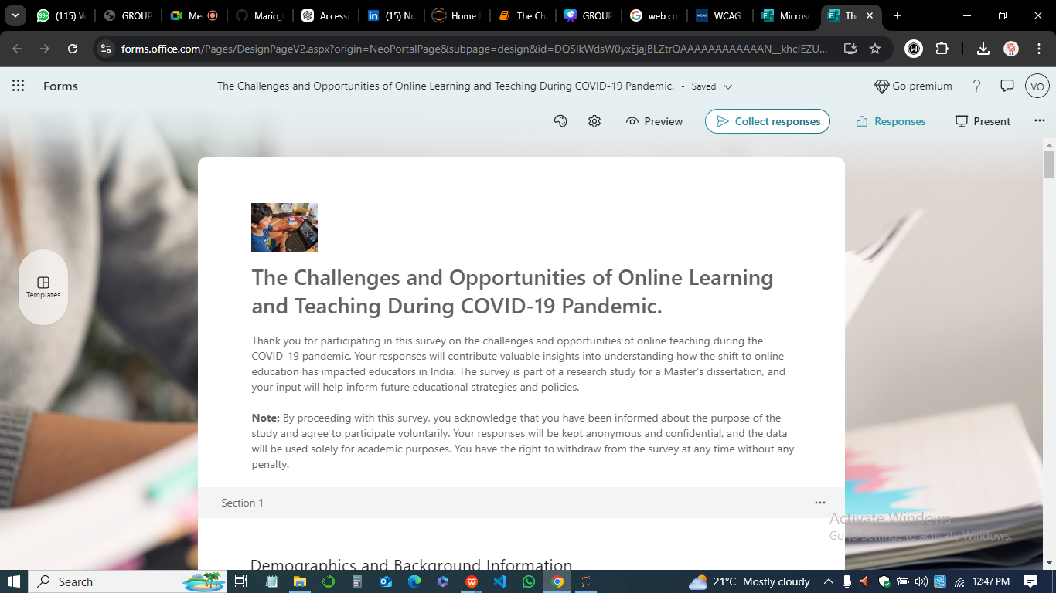

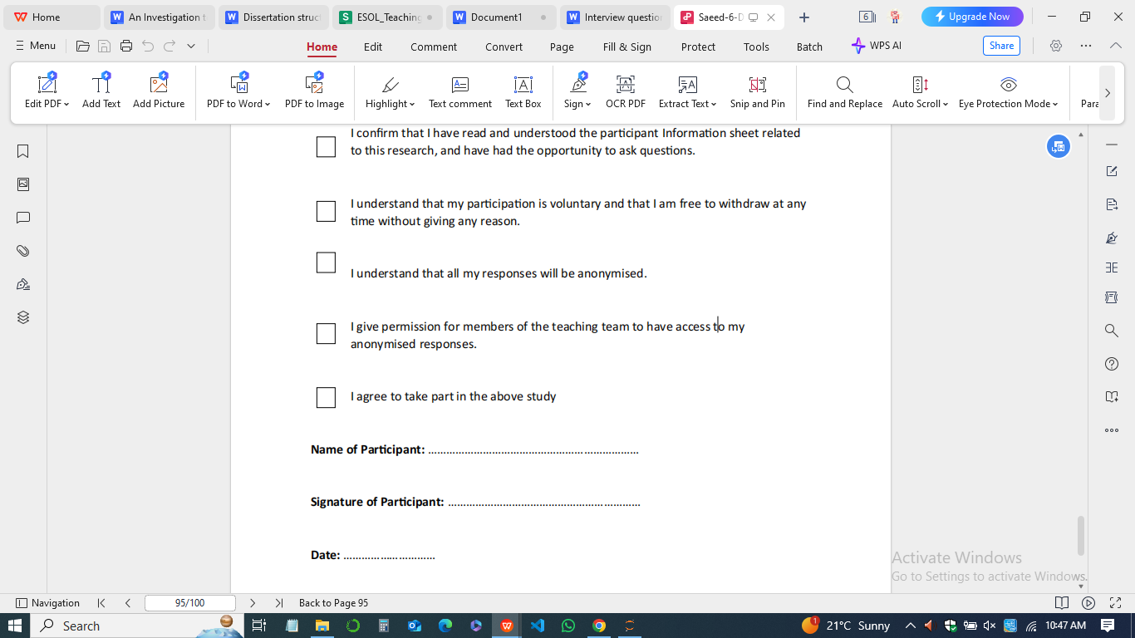

**Blank participant information sheet**

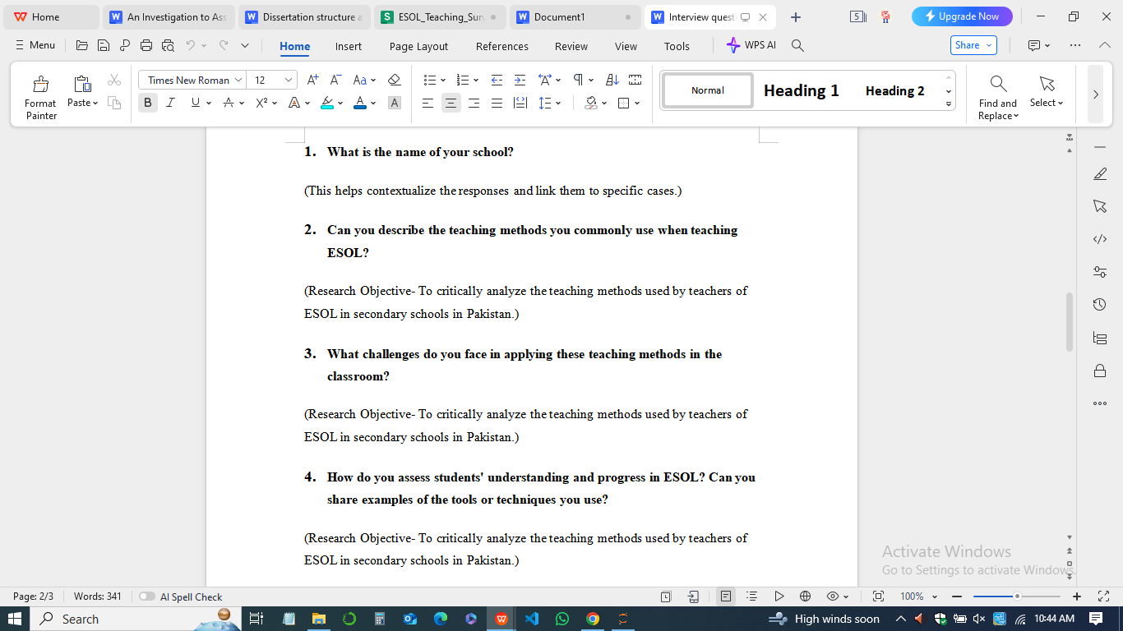

**Copies of blank questionnaires**



**Sample responses**

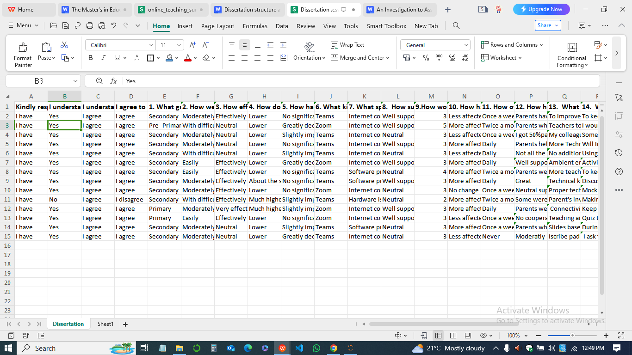

**Relevant policy or professional guidelines**

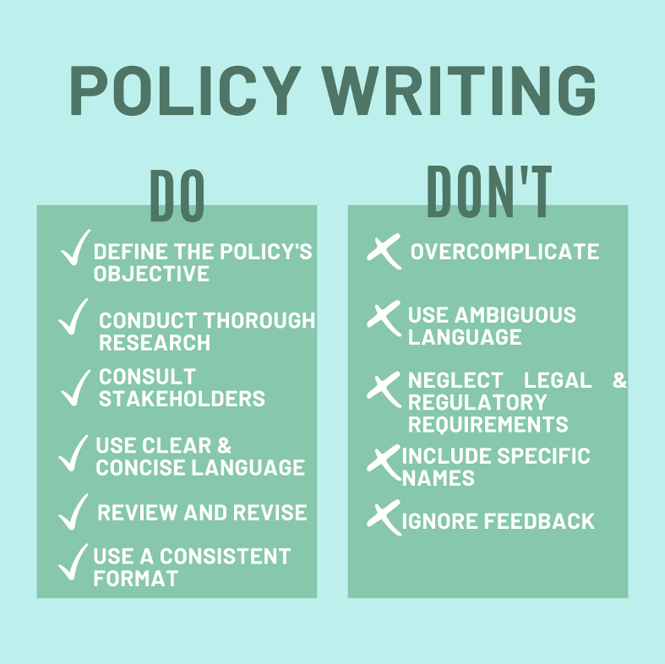

**\*\*\*\*THE END OF PAPER\*\*\*\***